DESIGN AND IMPLEMENTATION OF STUDENT'S DOCUMENT VERIFICATION SYSTEM BASED ON BLOCKCHAIN TECHNOLOGY

BY

NGWUBE MIRACLE ONYEDIKA
2021/SC/18901

DURU OGBUGHIKEM SAMUEL
2021/SC/19508

OGBOBE MIRACLE LINUS
2021/SC/21311

A PROJECT SUBMITTED TO DEPARTMENT OF COMPUTER SCIENCE/INFORMATICS IN PARTIAL FULFILMENT OF THE REQUIREMENT FOR THE AWARD OF THE DEGREE OF BACHELOR OF SCIENCE, ALEX-EKWUEME FEDERAL UNIVERSITY, NDUFU ALIKE, EBONYI STATE

SEPTEMBER, 2025.
DECLARATION
We, Ngwube Miracle Onyedika, Duru Ogbuhikem Samuel, and Ogbobe Miracle Linus an undergraduate student in the Department of Computer Science with Matriculation Numbers: 2021/SC/18901, 2021/SC/19508 and 2021/SC/21311 declare that the work embodied in this research report is original and has not been submitted in part or in full for any other Degree or Diploma of this University or any other Institution of higher learning.

________________________________ __________________________
Ngwube Miracle Onyedika Date

________________________________ __________________________
Duru Ogbuhikem Samuel Date

________________________________ __________________________
Ogbobe Miracle Linus Date

CERTIFICATION
This is to certify that this project work titled “Design and Implementation of Student Document Verification based on Blockchain Technology” was prepared, compiled and submitted by Ngwube Miracle Onyedika, Duru Ogbuhikem Samuel, and Ogbobe Miracle Linus with registration numbers 2021/SC/18901, 2021/SC/19508 and 2021/SC/21311 respectively to the department of Computer Science having been accepted on the meeting part of the requirement for the award of Bachelor in Science.

________________________________ __________________________
Prof. Obi Okonkwo Date
(Supervisor)

________________________________ __________________________
Dr. I. I. Achi Date
(Head of Department)

APPROVAL
This is to certify that this research titled “Design and Implementation of Students' Document Verification System Based on Blockchain Technology” was carried out by Ngwube Miracle Onyedika, Duru Ogbuhikem Samuel and Ogbobe Miracle Linus with Registration numbers 2021/SC/18901, 2021/SC/19508 and 2021/SC/21311, respectively. under the supervision in the Department of Computer Science/Informatics, Alex Ekwueme Federal University, Ndufu-Alike, Ebonyi State, Nigeria.
________________________________ __________________________
Prof. Obi Okonkwo Date
(Supervisor)

________________________________ __________________________
Mr. Afolabi Idris Yinka Date
(Project Coordinator)

________________________________ __________________________
Dr. I. I. Achi Date
(Head of Department)

________________________________ __________________________
Dr. A. N. Nwachukwu Date
(Dean)

________________________________ __________________________
Prof. F.N Ugwoke Date
(External Examiner)
DEDICATION

This project is dedicated to God Almighty, whose grace and guidance sustained us throughout this journey.

ACKNOWLEDGMENTS
First and foremost, we wish to convey our heartfelt gratitude to God Almighty, whose unwavering guidance and grace have seen us through this journey.
We genuinely appreciate our project supervisor Prof. Obi Okonkwo and our project coordinator, Mr. Afolabi Idris Yinka. Despite their demanding schedule, They offered invaluable academic insights, constructive feedback, and thoughtful recommendations that significantly enhanced this work.
Our heartfelt thanks also go to our Head of Department, Dr. I. I. Achi, for the opportunities and resources that were made available throughout this project. We extend our appreciation to all instructors in the Computer Science department for their unwavering commitment to education, which has broadened our knowledge and understanding.
To our parents, your relentless love, support, prayers, and encouragement have laid our foundation. We are eternally grateful for your sacrifices.
Lastly, we want to acknowledge everyone who contributed, in any capacity, to the success of this research. Whether your contribution was significant or modest, we are truly thankful.
Thank you all, and may God bless you abundantly.

ABSTRACT
This project presents the design and implementation of a student document verification system based on blockchain technology, which aims to address the limitations of traditional academic certificate verification methods. Conventional verification processes are often time-consuming, prone to forgery, and lack transparency and scalability. The proposed system, which is built with prototype methodology, leverages Ethereum blockchain smart contracts to store cryptographic hashes of student documents, ensuring immutability and tamper-proof verification. It features a role-based architecture with three primary users: admin, student, and verifier. Admins can upload certificate hashes to the blockchain, while verifiers can authenticate certificates by comparing document hashes. Student details and document files are stored securely off-chain in a PHP and MySQL-powered backend. The frontend, developed with React.js, allows real-time interaction with the blockchain through MetaMask wallet authentication. System testing confirmed the accuracy, performance, and security of the implementation. This research demonstrates how blockchain technology can provide a decentralised, efficient, and secure approach to academic document verification, offering significant improvements over existing manual systems.

TABLE OF CONTENTS
Title i
Declaration ii
Certification iii
Approval iv
Acknowledgement v
Dedication vi
Abstract vii
Table of Contents viii
List of Tables xiii
List of Figures xiv
CHAPTER ONE
INTRODUCTION
1.1 Background of the Study 1
1.2 Statement of the Problem 4
1.3 Aims and Objectives of the Study 5
1.4 Significance of the Study 5
1.5 Scope of the Study 7
1.6 Limitation of the Study 8
1.7 Definition of Terms 9
CHAPTER TWO
LITERATURE REVIEW
2.0 Introduction 10
2.1 Theoretical Background 11 2.1.1 Distributed Technology 11 2.1.2 Immutability Principle 11 2.1.3 The Public Key Infrastructure Theory 11 2.1.4 Smart Contracts 11 2.1.5 Trustless System Theory 12 2.1.6 Cryptographic Hashing 12
2.2 Review of Related Literature 13
2.3 Research Gap 16
CHAPTER THREE
RESEARCH METHODOLOGY, SYSTEM ANALYSIS AND DESIGN
3.1 Methodology 18
3.2 System Analysis 19
3.2.1 Data Gathering Technique 19
3.2.2 Analysis of the Existing System 21
3.2.3 Advantages of the Existing System 22
3.2.4 Disadvantages of the Existing System 24
3.2.5 High Level Model of the Proposed System 25
3.2.6 Analysis of the Proposed System 27
3.2.7 Justification of the Proposed System 29
3.3 System Design 31
3.3.1 Objective of the Design 31
3.3.2 System Architecture 32
3.3.3 Main Menu Design 34
3.3.4 Subsystem Design 35
3.3.4.1 Sub System and Design: Certificate Verification Sub System 35
3.3.5 Program Module Design 39
3.3.6 Database Development Tool 40
3.3.7 Database Design and Structure 43
3.3.8 Input / Output Format 44
3.3.9 Algorithm 46
3.3.10 Data Dictionary 49
CHAPTER FOUR
SYSTEM IMPLEMENTATION, TESTING AND RESULTS
4.1 System Implementation 52
    - Hardware Requirement 52
    - Software Requirement 53
    - Program Development 54
      - Choice of Programming Language 55
      - Language Justification 56
    - Main Menu Implementation 57
    - Sub Menu Implementation 58
    - Program Module Implementation 59
  - System Testing 60
    - Test Plan 61
    - Test Data 62
  - Test Results 64
    - Actual Test Results Versus Expected Test Results 64
    - Performance Evaluation 66
    - Limitation of the Result 67
    - Results and Discussion 68
  - System Security 68
  - System Integration 69

CHAPTER FIVE
SUMMARY, CONCLUSION AND RECOMMENDATIONS
5.1 Summary 71
5.2 Conclusion 71
5.3 Recommendations 72
Reference 74
APPENDIX
Appendix A: Source Code 76
Appendix B: Sample Output 81

LIST OF TABLES
Table 3.1: Sub-Menu for Admin Menus 40
Table 3.2: Sub-Menu for Student Menus 40
Table 3.3: Sub-Menu for Verifier Menus 41
Table 3.4: Off-chain User Data Table 56
Table 3.5: On-chain User Data Table 58
Table 3.6: Test Data Table 71
Table 3.7: Test Result Table 74

LIST OF FIGURES
Figure 3.1: Prototype Model Diagram 21
Figure 3.2: High-level Model Diagram of the proposed system 29
Figure 3.3: System Architecture 36
Figure 3.4: UI view of verification page 43
Figure 3.5: UI view of Certification upload page 45
Figure 3.6: Registration and Login Flowchart Diagram 53
Figure 3.7: Document Verification Flowchart Diagram 55
Figure 4.1: Landing page of the System 60
Figure 4.2: Student view Certificate page 67

CHAPTER ONE
INTRODUCTION
1.1 Background of the Study
In recent years, the verification of academic credentials has become a significant concern for educational institutions, employers, and students alike, due to the rise of fraudulent degree certificates and the misrepresentation of academic qualifications. Traditional methods of document verification rely on centralised databases, which are vulnerable to cyberattacks, data tampering, and inefficiencies (Rasool et al., 2020). The current systems employed by universities and educational institutions require significant manual effort, which results in time delays and increased administrative costs.
Additionally, centralised verification systems are prone to corruption, unauthorised modifications, and a lack of transparency in verifying student documents (Saleh et al., 2020). Blockchain technology provides a decentralised and tamper-proof solution to address these challenges, ensuring the transparency, security, and authenticity of student documents. Blockchain is a distributed ledger technology that records transactions in a secure, immutable, and transparent manner, making it an ideal solution for document verification in academic institutions (Shakan et al., 2021).
According to Camilleri and Grech (2018), “the Blockchain also represents an opportunity for third parties, such as employers, to independently and privately verify that shared records are authentic and unadulterated.” This characteristic positions blockchain as not only secure but also efficient for open verification, empowering external parties to validate academic records without relying on issuing institutions. Blockchain-based verification systems provide an efficient means of managing student records, reducing administrative workload, and preventing document forgery. Traditional verification methods involve multiple intermediaries, such as universities, regulatory bodies, and third-party verification services, which can cause delays and increase costs. Blockchain removes the need for intermediaries by allowing institutions to issue certificates directly on a decentralised ledger, enabling immediate verification by employers and other stakeholders (Rasool et al., 2020).
Additionally, blockchain technology guarantees that once a record is added, it cannot be edited or deleted, preventing fraudulent changes to academic credentials. Universities can store cryptographic hashes of degree certificates on a blockchain, allowing instant verification without exposing sensitive student data (Saleh et al., 2020).
Furthermore, the adoption of blockchain in student document verification enhances security and accessibility. Current systems often face issues related to data breaches, unauthorised access, and reliance on centralised storage, which increases the risk of data loss or manipulation (Shakan et al., 2021). Blockchain’s decentralised nature distributes data across multiple nodes, ensuring redundancy and security against cyberattacks.
In addition, smart contracts, self-executing contracts with predefined rules, can be implemented to automate the verification process, reducing human intervention and errors in document validation (Rasool et al., 2020). This automation ensures that only valid and authentic documents are approved for verification, reducing cases of academic fraud and misrepresentation of qualifications. The integration of blockchain technology into student document verification also improves efficiency and accessibility. Traditional verification methods often require physical documentation, mailing processes, and manual verification by institutions, which can be time-consuming and inconvenient for students and employers (Saleh et al., 2020). With blockchain-based verification, students can have lifelong access to their academic credentials on a secure and tamper-proof platform. Employers can verify certificates in real-time without needing to contact issuing institutions, streamlining the hiring process and reducing administrative overhead (Shakan et al., 2021).
Additionally, students can share their credentials with multiple entities without the risk of losing documents or dealing with bureaucratic delays. Globally, universities and governments are recognising the benefits of blockchain-based verification systems. Several initiatives have been launched to explore and implement blockchain for secure credential verification, ensuring the authenticity and validity of academic records (Rasool et al., 2020). The adoption of blockchain technology in higher education institutions is expected to revolutionise the document verification process, providing a reliable, secure, and efficient alternative to traditional systems.
In addition to universities, professional certification bodies and government agencies are also exploring blockchain as a viable solution to combat credential fraud and enhance trust in academic qualifications (Saleh et al., 2020). Despite the numerous advantages of blockchain technology in document verification, challenges remain in its widespread adoption. These include the initial implementation costs, the need for technological expertise, resistance to change by institutions, and interoperability concerns between different blockchain platforms (Shakan et al., 2021).
Nonetheless, ongoing research and development efforts are addressing these challenges, making blockchain a promising solution for student document verification in the near future. As more institutions recognise the benefits of decentralised verification, blockchain technology is expected to become a standard method for authenticating academic credentials, ensuring trust and integrity in the educational sector.

1.2 Statement of the Problem
The verification of student academic documents remains a critical issue in the educational sector, affecting both institutions and stakeholders such as employers and regulatory bodies. Based on literature and real-world observations, the following specific problems have been identified, which this study aims to address:
- Time-Consuming and Costly Processes: Many institutions still rely on manual and paper-based methods for document verification. These processes take time, involve high administrative costs, and are not convenient for students or employers (Rasool et al., 2020).
- High Risk of Academic Fraud: There is a growing problem of fake certificates and unverified credentials in circulation. This has made it difficult for employers and schools to fully trust academic documents without going through a stressful verification process (Saleh et al., 2020).
- Security Challenges in Centralised Systems: Current centralised systems used by many schools are vulnerable to cyberattacks, data tampering, and unauthorised access. This puts the integrity of student records at risk (Shakan et al., 2021).
- Difficulties with International Recognition: Students who travel abroad for work or further education sometimes face challenges in verifying their academic credentials. This is due to poor integration or cooperation between institutions across borders, limiting global mobility.
- Limited Use of New Technologies: Although blockchain has been identified as a potential solution, many institutions have not yet adopted it. This is mainly due to a lack of infrastructure, technical know-how, and concerns about data privacy and scalability (Rasool et al., 2020; Saleh et al., 2020).
Given these challenges, there is an urgent need for a secure, efficient, transparent, and user-friendly system that can reduce fraud and facilitate instant verification of academic documents for both local and international purposes.
1.3 Aim and Objectives of the Study
This study aims to design and implement a blockchain technology-based student document verification system that enhances security, transparency, and efficiency in academic certificate authentication. The specific objectives of the study are as follows:
- To analyse the limitations of existing document verification methods and their vulnerabilities to fraud.
- To design a blockchain-powered system that provides a decentralised and tamper-proof verification mechanism.
- To implement cryptographic hashing techniques for securing document authenticity.
- To develop a user-friendly interface for document issuers, verifiers, and students to interact efficiently with the blockchain system.
- To evaluate the effectiveness of blockchain technology in preventing academic fraud and unauthorised document modifications, as well as to assess the system's performance in terms of speed, security, and scalability compared to traditional verification methods.
1.4 Significance of the Study
The implementation of a blockchain-based student document verification system is significant in several ways, benefiting multiple stakeholders, including educational institutions, students, employers, and regulatory bodies. The contributions to each stakeholder group are outlined below:
- For Students:
  - Permanent and Secure Access to Records: Students gain lifelong access to their academic credentials stored securely on the blockchain, reducing reliance on physical certificates that may be lost or damaged.
  - Convenience in Sharing Credentials: With verifiable digital records, students can easily share their qualifications with multiple institutions or employers without repeated manual verification.
  - Protection Against Fraud: Since blockchain records cannot be altered, students are safeguarded against impersonation or the circulation of forged versions of their certificates.
- For Educational Institutions:
  - Reduced Administrative Burden: Institutions save time and resources previously spent on responding to verification requests through manual processes.
  - Strengthened Credibility: By issuing blockchain-backed certificates, institutions enhance their reputation and demonstrate commitment to innovation and transparency.
  - Efficient Record Management: The system enables universities to manage academic records securely, eliminating risks of data loss or manipulation in centralised databases.
- For Employers:
  - Faster Hiring Processes: Employers can instantly verify the authenticity of academic credentials without waiting for universities to respond to requests.
  - Increased Confidence in Credentials: Blockchain verification ensures that the certificates presented by applicants are authentic, reducing the risk of hiring individuals with forged qualifications.
  - Cost Efficiency: By removing the need for third-party verification agencies, employers reduce recruitment costs and speed up decision-making.
- For Regulatory Bodies and Government Agencies:
  - Standardisation of Verification: The system provides a unified framework that regulatory bodies can adopt across multiple institutions to ensure consistency in credential authentication.
  - Transparency and Accountability: Immutable blockchain records guarantee that academic credentials remain verifiable throughout graduates’ lifetimes, supporting institutional accountability.
  - Support for Policy Enforcement: Regulators can leverage the system to track compliance with educational standards and prevent malpractice in certificate issuance.
1.5 Scope of the Study
This study focuses on the design and implementation of a blockchain-based student document verification system for verifying academic certificates. It aims to enhance security, efficiency, and transparency in academic certificate authentication. The scope is limited to exploring blockchain technology as an alternative to traditional verification methods, analysing its potential to prevent document fraud and improve accessibility.
The study is guided by the objectives of developing a decentralised verification system, assessing its effectiveness in reducing administrative workload, and evaluating its ability to prevent unauthorised modifications of student credentials. The system is developed using React.js for the frontend interface, PHP and MySQL for backend processing and off-chain storage, and Ethereum smart contracts written in Solidity for on-chain certificate hashing and verification. For blockchain interaction, MetaMask is integrated for wallet authentication, while Ganache and Truffle are used for testing and deployment of smart contracts.
This research is applied to a specific case study involving the implementation and testing of a prototype system within Alex Ekwueme Federal University or other academic institutions in Nigeria.
However, the scope of this study does not extend to other emerging technologies beyond blockchain, such as artificial intelligence or biometrics, nor does it include broader applications outside academic document verification.
1.6 Limitations of the Study
While the existing studies present an innovative approach to student document verification through blockchain technology, they are subject to several limitations.
- Institutional Integration Challenges: The study is limited by the challenges associated with the adoption and integration of blockchain technology within academic institutions. Many universities operate on legacy systems that may not be easily compatible with blockchain-based solutions, leading to potential difficulties in implementation (Rasool et al., 2020).
- Technical and Resource Constraints: Blockchain technology requires significant computing resources and technical expertise, which may pose financial and operational challenges for some institutions, particularly those in developing regions like our country.
- Regulatory and Legal Uncertainty: Different countries and educational systems have varying policies regarding data privacy, digital records, and blockchain adoption, which could impact the scalability and acceptance of the proposed system (Saleh et al., 2020). In our country, there is no direct law against blockchain verifications, but the general data privacy laws, such as the Nigeria Data Protection Act (NDPA) 2023. and related regulations apply to the data processed on blockchains, ensuring privacy and security.
- Regulatory and Legal Uncertainty: Blockchain transactions, while immutable and secure, require consensus mechanisms and network validation, which may introduce delays in document verification compared to existing centralised systems. The study is also constrained by the relatively new adoption of blockchain in education, meaning that extensive empirical data on large-scale implementations may not yet be available.
- Data Entry Errors: Additionally, while blockchain ensures immutability, it does not prevent errors in data entry; once incorrect information is recorded, it remains permanent unless corrective mechanisms are in place (Shakan et al., 2021).
1.7 Definition of Terms
- Document Verification System: A mechanism used to authenticate the legitimacy of academic credentials, ensuring that issued documents are genuine and free from forgery.
- Blockchain Technology: A decentralised, distributed ledger system that records transactions securely and immutably across a network of computers, preventing unauthorised alterations to stored data.
- Decentralisation: The principle of distributing data across multiple nodes in a network, eliminating the reliance on a single authority or centralised server for managing records.
- Cryptographic Hashing: A security technique used in blockchain technology to convert data into a fixed-length unique code, ensuring that any alterations to stored information are easily detectable.
- Smart Contracts: Self-executing digital contracts embedded within a blockchain, containing predefined rules that automate processes such as verifying and validating academic records.

CHAPTER TWO
LITERATURE REVIEW
2.0 Introduction
This chapter reviews existing literature on blockchain-based student document verification systems, discussing the fundamental principles of blockchain technology, current challenges in document verification, and the role of smart contracts in authenticating academic credentials. It also examines traditional verification methods, blockchain alternatives, and the integration of smart contracts for automation and trust in digital education credentials.
2.1 Theoretical Background
The theoretical foundation of blockchain-based document verification lies in several key concepts, which include the conceptual and technological terms:
2.1.1 Distributed Technology: The Distributed Ledger Technology (DLT) model is one of the core theories which supports the decentralised storage of data across multiple nodes without relying on a central authority. This model ensures that data is secure, transparent, and accessible by all authorised participants (Saleh, Ghazali, & Rana, 2020). In educational systems, this means that both employers and academic institutions can verify student credentials independently and securely without the need for intermediaries.
2.1.2 Immutability Principle: Another relevant theory is the Immutability Principle, which emphasises that once information is recorded in a blockchain, it cannot be altered or deleted. This immutability ensures the integrity of academic records and helps prevent document forgery (Wahyuningsih, Oganda, & Anggraeni, 2021). The use of cryptographic hashing further strengthens this concept, where document data is transformed into unique hash values that make it easy to detect any unauthorised changes (Deenmahomed, Didier, & Sungkur, 2021).
2.1.3 The Public Key Infrastructure Theory: The Public Key Infrastructure (PKI) theory is also crucial, as it involves the use of digital signatures and encryption techniques to secure document data and restrict access. In blockchain systems, public and private keys are used to manage identity and access control, allowing only authorized users to verify credentials (Hsu, Tu, & Chiu, 2022).
2.1.4 Smart Contracts: Smart Contract Theory contributes significantly to the automation of credential issuance and verification. Smart contracts are self-executing programs that follow predefined rules and trigger automatic actions, such as issuing certificates or verifying documents, once specific conditions are met (Rasool et al., 2020). This helps eliminate human intervention, reduce processing time, and prevent errors.
2.1.5 Trustless System Theory: The Trustless System Theory supports the idea that blockchain does not require participants to trust each other. Instead, trust is placed in the technology itself, which operates based on transparent and verifiable protocols. In student document verification, this means stakeholders can validate credentials without needing to verify the issuing institution directly (Cahyadi, Faturahman, Haryani, & Dolan, 2021).
2.1.6 Cryptographic Hashing: The use of cryptographic hashing further strengthens the concept of immutability, where document data is transformed into unique hash values that make it easy to detect any unauthorised changes (Deenmahomed, Didier, & Sungkur, 2021).
Together, these theories provide a solid academic foundation for understanding the application of blockchain in education and justify its use in designing secure, decentralised, and tamper-proof systems for student document verification.
2.2 Review of Related Literature
Several studies have explored the design and implementation of blockchain-based student document verification systems, addressing challenges such as document forgery, verification inefficiencies, and identity fraud.
One of the earliest frameworks was introduced by Zheng (2021), who proposed a permissioned blockchain model for academic credential authentication using Hyperledger Fabric. This system enabled universities to issue tamper-proof certificates that could be instantly verified by authorised parties. The use of Hyperledger Fabric allowed for high transaction throughput, modular consensus mechanisms like RAFT, and strong access control through a certificate authority. These features made it ideal for enterprise applications in education. However, the model’s complexity and the centralised control over permissions raised concerns about trust and transparency. Additionally, misconfigurations in permissioned networks could potentially introduce security vulnerabilities (Zheng, 2021).
Alshahrani (2021) developed a public blockchain-based e-diploma system that leveraged Ethereum smart contracts to ensure transparent and immutable credential verification. The decentralised nature of Ethereum allowed any third party to verify the authenticity of a certificate without relying on the issuing institution. This openness is a key strength, fostering trust and interoperability. However, the system faced significant scalability issues, particularly due to high gas fees and network congestion on the Ethereum mainnet, making it less feasible for institutions handling large volumes of student data (Alshahrani, 2021).
To address these scalability concerns, Ghazali and Saleh (2018) proposed a hybrid blockchain model that combined off-chain document storage with on-chain hash anchoring. In their design, the full document is stored in a separate off-chain system, while its cryptographic hash is anchored on the blockchain. This approach reduces the computational and financial cost of storing large files directly on-chain while preserving integrity and traceability. However, it introduces a dependency on the availability and security of the off-chain storage system. If the off-chain files are not properly managed or pinned (as in IPFS), verification becomes impossible, thereby undermining trust in the system (Ghazali & Saleh, 2018).
Building on the hybrid model, Lamkoti et al. (2021) implemented a transcript verification system that integrates the InterPlanetary File System (IPFS) for decentralised document storage. By storing certificates on IPFS and anchoring their hashes to a blockchain, the system ensures tamper-proof document verification while minimising blockchain storage costs. The content-addressed storage of IPFS ensures immutability and decentralisation. However, unless documents are pinned or actively hosted by persistent nodes, they may become inaccessible. Furthermore, privacy concerns arise if certificates are not encrypted before being uploaded to IPFS (Lamkoti et al., 2021).
In another study, Bucea-Manea-Țoniş et al. (2021) introduced the Blockchain Smart Curriculum System (BCS), which focused on automating the accreditation verification process. Their system was designed to ensure that only recognised and certified institutions could issue valid academic credentials. This significantly reduced the threat posed by diploma mills and fake universities. The system’s strength lies in its institutional accountability and the assurance it provides to verifiers. However, its success heavily depends on the accurate maintenance of an up-to-date, trusted list of certifying institutions, which could pose governance and interoperability challenges across borders (Bucea-Manea-Țoniş et al., 2021).
Awaji et al. (2020) developed a self-sovereign identity (SSI) system that allows students to have direct ownership and control of their academic records. In this model, students can selectively share credentials with prospective employers or educational institutions without relying on a central authority. This approach enhances user privacy and empowers students in managing their data. However, it also introduces the risk of credential loss if users misplace their private keys. Furthermore, revoking or updating shared credentials remains a challenge in self-sovereign models without additional infrastructure (Awaji et al., 2020).
Chowdhary et al. (2021) presented a system that integrated biometric authentication and facial recognition into a blockchain-based identity framework for verifying student credentials. By linking biometric identifiers to blockchain entries, the system added a strong layer of identity verification, preventing impersonation and unauthorised access. The key advantage of this model is its ability to tightly bind credentials to a unique, verified individual. However, biometric systems raise serious concerns about data privacy and legal compliance, particularly under regulations such as GDPR. Moreover, implementation requires advanced infrastructure and incurs additional costs (Chowdhary et al., 2021).
Zheng (2021) also explored the application of Zero-Knowledge Proofs (ZKPs) in academic credential verification. ZKPs allow one party to prove that they possess valid credentials without revealing the actual data. This is particularly useful in privacy-sensitive environments such as academic systems. The strength of this method lies in its privacy-preserving nature, which enables verification without compromising data confidentiality. Nevertheless, ZKPs are still relatively new and involve complex cryptographic techniques, which may result in slower performance and require significant processing power to implement effectively (Zheng, 2021).
In a related innovation, Alshahrani (2021) proposed using non-fungible tokens (NFTs) to represent academic certificates on the Ethereum blockchain. Each certificate issued was a unique digital asset, verifiable through public blockchain explorers. This approach offers verifiable ownership, durability, and easy access. However, minting NFTs on Ethereum is costly due to high gas fees, and publicly viewable NFT certificates might unintentionally expose personal information unless precautions are taken (Alshahrani, 2021).
Finally, researchers such as Ghazali and Saleh (2018) and Bucea-Manea-Țoniş et al. (2021) emphasised the need for cross-chain interoperability and quantum-resistant blockchain protocols. These technologies aim to improve the global scalability and future-proofing of academic verification systems. Cross-chain solutions enable credentials to be verified across multiple blockchain platforms, thereby enhancing usability. Quantum resistance prepares systems for a future where quantum computers could potentially break current cryptographic standards. Despite these advancements, practical implementation remains limited, and standardisation efforts are still evolving (Ghazali & Saleh, 2018; Bucea-Manea-Țoniş et al., 2021).
2.3 Research Gap
Despite the advancements in blockchain-based student document verification systems, several research gaps remain, requiring further investigation. While existing studies have explored blockchain-based document verification systems, most are limited to theoretical frameworks, foreign case studies, or highly technical blockchain models that do not address the real challenges faced by Nigerian academic institutions, including Alex Ekwueme Federal University, Ndufu-Alike, Ikwo. Existing works do not provide a decentralised yet practical solution that:
- integrates role-based access (admin, student, verifier).
- combines on-chain hashing with off-chain secure storage.
- ensures real-time verification without the delays of manual processes.
This creates a gap in research on developing a scalable, user-friendly, and context-specific blockchain-based student document verification system for Nigerian universities.

CHAPTER THREE
RESEARCH METHODOLOGY, SYSTEM ANALYSIS AND DESIGN
3.1 Methodology
This chapter presents the methodology adopted for the design and implementation of a blockchain-based student document verification system. The methodology employed in this project is a Prototype Model of software development. This model was chosen because of its iterative nature and its flexibility in incorporating user feedback throughout the development lifecycle. The project involves blockchain technology, which requires thorough interaction with end users (e.g., administrators and verifiers) to ensure the final product meets expectations for trust, usability, and data security.
In the prototype model, an initial version of the system is quickly built with core functionalities such as wallet connection, document upload, and document verification on the Ethereum blockchain using smart contracts. This version is then improved based on testing and user evaluation. This approach allows for refining the smart contract interaction, UI/UX experience, and system workflow before arriving at a fully developed version.
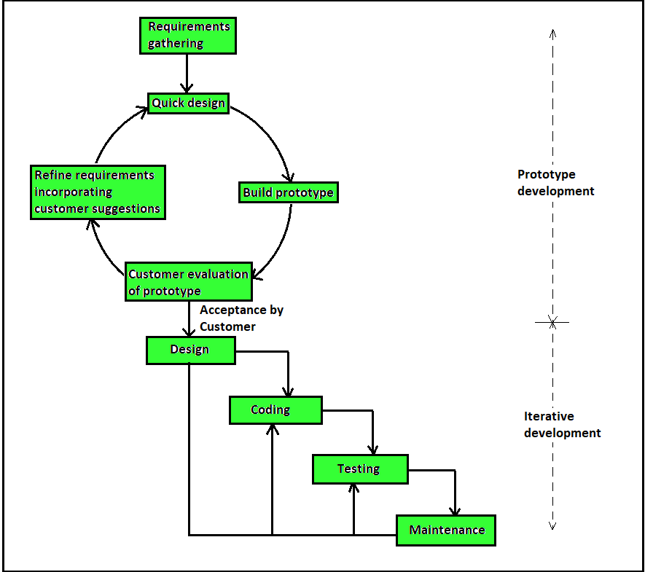
Figure 3.1: Prototype Model Diagram
3.2 System Analysis
System analysis is a critical phase in the system development lifecycle. It involves the examination and interpretation of existing operation, identifying areas of improvement, gathering relevant information from stakeholders, and proposing technological solutions that address the identified gap. In the context of this study, the design and implementation of student document verification system based on blockchain technology, a detailed system was conducted to ensure that the proposed system addresses users needs and operates effectively within a controlled environment.
3.2.1 Data Gathering Technique
To accurately understand the problem domain and gather the necessary requirements for the design and implementation of a student document verification system based on blockchain technology, a combination of qualitative and quantitative data gathering techniques was employed. These techniques ensured that the system would be developed based on real-world needs, user expectations, and technological viability. The following data collection methods were used:
- Interviews: Structured and semi-structured interviews were conducted with key stakeholders, including university administrators, registry officials, and document verification officers. These interviews were aimed at understanding the current processes involved in issuing and verifying academic documents, the limitations of traditional systems, and the expectations for a modern digital solution. The insights gained revealed specific pain points such as document forgery, delays in manual verification, lack of centralised access, and difficulty in cross-institution validation. The qualitative feedback from stakeholders helped define system goals such as transparency, data immutability, ease of verification, and decentralised access.
- Observation: Direct observation of current document verification sessions in the university’s academic registry provided valuable insights into the real-time workflow, human interactions, and operational bottlenecks. Through close monitoring of staff during the verification process, issues such as delays caused by missing records, repetitive paper checks, and a lack of traceability were identified. These observations informed the design of system features such as automated document lookup, time-stamped validation records, and smart contract-based data storage.
- Literature Review: A thorough review of existing academic works, technical documentation, and case studies related to blockchain-based document verification systems was carried out. This helped establish a theoretical foundation for the project, informed system design choices, and identified existing challenges and proposed solutions in the field. Notably, the literature provided insights into the benefits of decentralised verification, the role of smart contracts, privacy concerns, and consensus mechanisms. The literature review also helped in identifying research gaps that this system attempts to address.
- Online Survey: A structured online questionnaire was distributed to students, registry staff, and prospective employers. The aim was to gather quantitative and qualitative data on their expectations, awareness, and experience with digital documentation and verification systems. The survey included questions on current document access methods, concerns about document security, user friendliness of digital systems, and willingness to adopt blockchain-based verification platforms. Responses from over 70 participants highlighted a strong demand for faster, transparent, and verifiable document issuance. The data collected helped prioritize features such as user authentication, real time verification, and downloadable digital certificates.
3.2.2 Analysis of the Existing System
The traditional document verification process in most academic institutions, including Alex Ekwueme Federal University Ndufu-Alike (AE-FUNAI), involves manual checking of printed credentials and is largely centralised. Students typically submit hard copies of their transcripts, certificates, or result statements to requesting organisations. The organisations or individuals seeking to verify a student's academic certificate must submit a request either physically or electronically to the university's academic registry or exams and records unit. This request typically includes a copy of the certificate or transcript in question and a formal letter specifying the reason for verification.
Upon receiving such a request, university staff must manually check institutional records, either in digital form or in hard copy files, to confirm the authenticity of the documents. After verification, a confirmation letter is usually sent to the requesting organisation via email, post, or hand delivery. While this method is a step forward from completely manual paper-based processes, it still suffers from significant drawbacks, including:
- Time-Consuming Process: Verification requests can take days or even weeks to process, depending on staff availability, document access speed, and the institution’s internal bureaucratic procedures. This often results in delays for students seeking job placements, visa applications, or postgraduate admissions.
- High Risk of Document Forgery: Current systems often lack robust cryptographic protection mechanisms. As a result, forged certificates can sometimes pass initial screening, especially when the verification relies solely on emailed images, scanned or physical documents. This undermines the institution’s credibility and the trustworthiness of its graduates.
- Resource-Intensive and Inefficient: The existing system requires continuous human effort to respond to verification requests, search records, and compose official responses. This not only places a heavy administrative burden on staff but also makes the process costly in terms of manpower and time.
- Lack of Transparency and Auditability: Once a document is verified, there’s often no public record or transparent audit trail showing who verified it, when it was verified, or how. This makes dispute resolution and validation less reliable for third parties.
3.2.3 Advantages of the Existing System
While the current centralised document verification process in various Nigerian institutions, including Alex Ekwueme Federal University Ndufu-Alike (AE-FUNAI), has notable drawbacks, it also offers certain advantages that have contributed to its continued use. These benefits, though limited in scope, have made the system functional and, in some contexts, preferable to certain stakeholders. Below are some of the key advantages:
- Requires no internet or specialised devices: One of the notable strengths of the existing system is its low technological dependency. The process relies primarily on physical documentation and human verification, which means it does not require constant access to the internet or advanced digital infrastructure. In environments with poor internet connectivity, a common challenge in some parts of Nigeria, this can be seen as a practical advantage. Administrative staff can access and verify records manually without relying on online systems or databases that may be unreliable or inaccessible due to network outages.
- Familiarity and Trust in Physical Documentation: Many traditional organisations, especially government agencies, embassies, and older employers, still place high trust in physical certificates and printed documents. They may consider printed originals with institutional stamps and signatures as more authentic and harder to falsify than digital files, which can be easily edited using software. The existing system aligns with existing trust frameworks. When verifications are done using physical records and confirmed with official letters bearing the university’s seal, recipients often feel reassured of the document’s legitimacy.
- Minimal Technical Skill Requirements: Another advantage of the current system is that it does not require technical expertise on the part of either the verifier or the verifying staff. Staff members who are not trained in modern IT or blockchain systems can still operate within the manual process effectively. Likewise, requesting organisations do not need to interact with a user interface or understand how digital verification tools work; they simply receive a written confirmation from the institution.
3.2.4 Disadvantages of the Existing System
While the existing document verification system used by many academic institutions in Nigeria has certain advantages, it also presents several significant drawbacks. These shortcomings undermine the efficiency, security, and scalability of the verification process. Below are the major disadvantages associated with the current system:
- High potential for document forgery: One of the most critical issues with the existing system is the ease with which academic documents can be forged. Because physical certificates, transcripts, and other credentials are often printed and manually distributed, malicious actors can replicate or alter these documents with relative ease using graphic design software, fake institutional seals, or forged signatures. The absence of cryptographic security or digital fingerprints means there is no automated way to verify authenticity, making the system vulnerable to fraud and undermining public trust in the academic credentials issued by Nigerian institutions.
- Time delays in verification due to manual handling: The current verification process is labour-intensive and slow. When an organisation or employer sends a verification request, the institution must manually search paper files or centralised databases, verify the information, and draft a response letter. This entire process may take days or even weeks, especially in cases where records are difficult to locate or administrative backlogs exist. For students and graduates, this delay can be detrimental, especially when seeking job opportunities, applying for international scholarships, or meeting tight deadlines for school admissions. In a competitive world where speed is often critical, the slow turnaround time becomes a major disadvantage.
- Lack of transparency and traceability: Another major limitation is the absence of transparency and traceability in the verification process. Once a verification request is sent, there is usually no structured way to track its progress. Applicants and requesters are often left in the dark about the status of their request unless they follow up with phone calls or emails. Additionally, there is no verifiable log showing who accessed a record, when, and for what purpose. This lack of auditability creates a breeding ground for inefficiencies, delays, and even corruption, as some individuals may request unofficial payments to speed up the process.
- High workload for university staff: Because the process is not automated, academic and administrative staff are forced to manually process every verification request, regardless of volume. This leads to a high workload, particularly in large universities with thousands of graduates and frequent external requests. This overload diverts staff attention from other critical duties and can reduce overall productivity. It also increases the chances of human error, including record mismatches, incorrect responses, or misplacement of files.
3.2.5 High-Level Model of the Proposed System
The proposed student document verification system based on blockchain technology is designed to address the weaknesses of the existing manual and centralised system by introducing decentralisation, immutability, transparency, and automation using blockchain technology.
The core idea of the proposed system is to use blockchain smart contracts, specifically on the Ethereum network, to store hashed representations of academic documents. These hashes act as digital fingerprints of the documents, allowing any third party to verify a document’s authenticity without needing access to the original database of the institution. The frontend application serves as an interface for students, administrators, and verifiers to interact seamlessly with the smart contract.
- Student Registration and Document Download Module: A student logs into the system using a blockchain wallet (e.g., MetaMask), which provides a unique public wallet address. The student fills out their details, such as name, matric number, and department, and registers this data along with their wallet address on the Database. The student can then download the academic certificate through the frontend interface once it is uploaded by the Admin.
- Admin and Certificate Upload Module: The Admin uploads academic certificates for each registered student from the admin dashboard. The hash of the certificate is calculated and stored immutably on the blockchain, linking it with the student’s wallet address. The original PDF certificate and metadata (e.g., student ID, document title, issue date) are stored in the backend database.
- Verifier Document Validation Module: A third-party verifier, such as an employer or other institution, accesses the verification interface on the frontend. They upload a copy of the academic document provided by the student. The system hashes the uploaded file and checks whether the generated hash matches any document hash stored on the blockchain. If a match is found, the system confirms the document’s authenticity and displays relevant metadata (e.g., student name, department, date of issuance). If no match is found, the document is flagged as not verified or possibly forged.
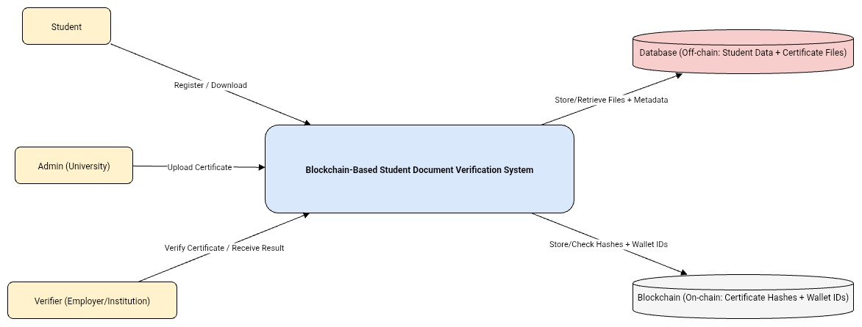
Figure 3.2: High-Level Model Diagram of the Proposed System (Level 0 DFD).
3.2.6 Analysis of the Proposed System
The proposed system introduces a paradigm shift from traditional manual verification to a decentralised, secure, and efficient framework. This section analyses the features, benefits, and structural innovations of the system:
- Trustless Verification: One of the most significant advantages of blockchain technology is the ability to perform trustless operations. In the context of document verification. Verifiers do not need to contact the issuing institution, such as AE-FUNAI, to validate a certificate. The system computes the hash of the uploaded document and checks if it exists in the blockchain. If the hash matches an existing on-chain record, authenticity is confirmed without requiring further human intervention. This reduces reliance on third-party institutions or manual confirmation processes.
- Enhanced Security and Privacy: The system does not store the actual documents on the blockchain, which is a critical privacy measure. Instead, it uses cryptographic hashing algorithms like SHA-256 to generate a unique digital fingerprint of the certificate also called hash. This hash is then immutably stored on the Ethereum blockchain, ensuring that:
  - Any alteration to the original document changes the hash, instantly detecting tampering.
  - The integrity of the certificate is preserved.
  - Documents themselves are stored securely in a backend server/database using PHP & MySQL, accessible only to authorised parties.
- Multi-User Role Structure: The system defines and enforces different access levels and capabilities based on user roles:
  - Admin: Uploads and hashes student certificates. Maintains both on-chain and off-chain records for consistency.
  - Student: Registers on the platform using their wallet address. Access their dashboard to download academic certificates. Share these documents externally with potential employers or other institutions.
  - Verifier: Uploads a document received from a student to the platform. The system hashes the file and checks its validity against the stored on-chain hashes. A success or failure result is instantly shown, confirming whether the document is genuine. This role-based access ensures clarity, accountability, and functional separation.
- Decentralisation and Immutability: By relying on the Ethereum blockchain, the system benefits from decentralisation. Hashed documents are not controlled by a single entity or stored in a single database that could be altered or compromised. Once a document hash is written to the blockchain:
  - It cannot be deleted, modified, or tampered with, ensuring long-term validity.
  - Multiple stakeholders, including verifiers, alumni, government agencies, etc., can independently confirm document authenticity once shared with them.
  - Even if the institution's internal system or server is down, the blockchain remains accessible, preserving verification capabilities.
3.2.7 Justification of the Proposed System
The justification for implementing a blockchain-based student document verification system stems from the inefficiencies, vulnerabilities, and lack of transparency associated with traditional centralised methods. The proposed system offers a technologically advanced solution that not only addresses these issues but also introduces innovative features to meet the growing demand for secure, instant, and decentralized verification. Below is a comprehensive justification:
- Tamper-Proof Verification via Blockchain: Traditional systems rely heavily on centralized databases or paper-based records, which are prone to manipulation, forgery, or accidental loss. The proposed system utilises blockchain technology to store cryptographic hashes of documents, making the verification process tamper-proof. Once a hash is stored on the blockchain, it becomes immutable; it cannot be altered, deleted, or faked. As a result, any attempt to present a forged or altered certificate is easily detectable, as the hash will not match the original stored on-chain. This ensures that only authentic, institution-approved certificates can pass the verification process.
- Significant Reduction in Verification Time: Manual certificate verification typically involves communication between institutions, handling physical documents, and long waiting times, which can take days or even weeks. With the proposed system:
  - The verifier simply uploads the certificate file.
  - The system immediately computes the hash and compares it with on-chain records.
  - If a match is found, verification is completed within seconds.
This drastic improvement in speed increases efficiency for both institutions and employers, especially during large scale recruitment or admission exercises.
- Privacy and Ownership Through User-Controlled Wallets: In conventional systems, student data and certificates are often stored and managed centrally, without giving the student control or transparency. In the proposed system:
  - Each student registers using their blockchain wallet address, which becomes their unique digital identity.
  - The student retains ownership of their certificates and can access or share them independently.
  - Since the full documents are stored off-chain and only their hashes are on-chain, sensitive personal data is protected.
This aligns with modern privacy standards such as NDPA (Nigeria Data Protection Act), ensuring that users retain control over their information while still enabling robust verification.
- Building Trust with Employers and Verifying Institutions: One of the core challenges in document verification is trust employers and third-party organisations often need to verify credentials without prior relationships with the issuing institutions. By utilising blockchain:
  - The system becomes trustless, meaning verification does not depend on trust in a single institution or intermediary.
  - Stakeholders can rely on the transparency and cryptographic certainty provided by blockchain technology.
  - Since the data is verifiable on a public or permissioned blockchain, third parties can perform independent verification without relying on offline communication or authorization.
This builds long-term confidence in the institution’s verification process and enhances its credibility globally.
3.3 System Design
The system design stage translates the requirements of the student document verification system based on blockchain technology into a structured framework that guides implementation. This stage focuses on outlining the system architecture, data flow, and functional components required to ensure security, transparency, and efficiency in certificate management. The design emphasizes both the on-chain (blockchain) and off-chain (database) interactions, ensuring a balance between decentralization and practical storage needs.
3.3.1 Objective of the Design
The objective of the system design is to create a secure, user-friendly, and decentralised application that enables reliable academic document verification using blockchain technology. The design aims to address the shortcomings of the existing manual verification system by introducing a trustless, automated solution that ensures data integrity, privacy, transparency, and accessibility. Specifically, the design focuses on the following objectives:
- Ensure Data Integrity: By leveraging blockchain, particularly Ethereum smart contracts, the system guarantees that uploaded certificate hashes cannot be tampered with, providing a reliable source of truth for verifiers.
- Improve Verification Speed: The system is designed to perform instant document verification by comparing uploaded document hashes with on-chain data, reducing verification time from days to seconds.
- Promote Decentralisation: The system removes the need for manual verification or institutional approval by using smart contracts to validate document authenticity.
- Enhance User Roles and Access Control: The system supports multiple user types (Admin, Student, Verifier) with distinct access privileges and functionality, improving usability and operational security.
- Ensure Student Privacy and Ownership: Through wallet-based authentication and off-chain storage of personal data, students retain control over their records while enjoying the benefits of blockchain-backed verification.
- Support Hybrid Data Storage: The system combines on-chain (document hash) and off-chain (PDF certificate and metadata) components to maintain both privacy and performance efficiency.
3.3.2 System Architecture
The system architecture of the student document verification system based on blockchain is designed using a three-tier architecture model, incorporating the frontend, backend, and blockchain network layers. This hybrid architecture allows the system to integrate decentralised blockchain features for trustless verification, while still leveraging the efficiency and flexibility of centralised components for file storage and user management. The system consists of the following major components:
- Presentation Layer (Frontend): The frontend serves as the user interface through which all stakeholders interact with the system. It is built with React.js and supports the following users:
  - Admin: Uploads and manages student records, stores document hashes on the blockchain.
  - Student: Registers with a wallet address and views/downloads their certificate.
  - Verifier: Uploads a certificate to verify against on-chain hashes.
The key functionality of this frontend/presentation Layer is:
  - MetaMask Wallet connection (Web3 authentication)
  - Certificate upload and download
  - Real-time verification result display
  - Admin dashboard for student and certificate management
- Application Layer (Backend): The backend handles the storage of student metadata (name, matric number, department, etc.) And the actual certificate files (PDF, Linking uploaded certificates with student wallet addresses and File validation and upload management
- Data Layer (Blockchain): Smart contracts written in Solidity are deployed on the Ethereum blockchain, which was tested locally using Ganache and Truffle for development. This layer is responsible for:
  - Registering student wallet addresses
  - Storing certificate SHA-256 document hashes
  - Retrieving stored hashes for verification
  - Ensuring immutability and transparency
The way all the components interact is that the student registers an account by connecting the wallet via MetaMask on the frontend and filling in the necessary details (metadata). Then, their information is collected and stored in the backend database, and the wallet address is registered on-chain via a smart contract. But if already registered, the student is redirected to the student dashboard, where they have access to download their certificates when uploaded.
Admin uploads student certificate (PDF). The system then computes the hash of the file. Stores the file and metadata off-chain in the database and then calls the smart contract function to store the hash on-chain, linked to the student’s wallet.
When the Document Verifiers come to the system to verify a student certificate, the verifier uploads a certificate file on the frontend. The system computes the hash of the uploaded file instantly. The frontend queries the blockchain for matching hashes using the smart contract. If a match exists, the certificate is deemed authentic.
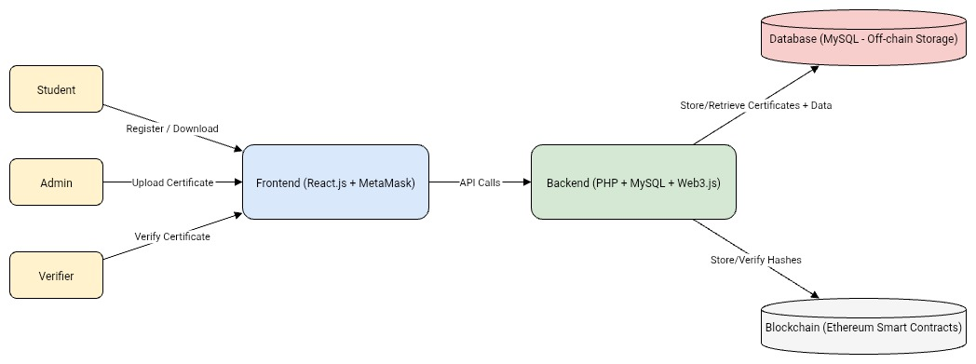FIGURE 3.3: System Architecture
3.3.3 Main Menu Design
The Main Menu Design serves as the central navigation hub of the student document verification system. It is designed with usability, clarity, and accessibility in mind, allowing users to easily access key system functionalities based on their roles. The main user types, Admin and Student, are directed to role-specific dashboards upon successful login or wallet connection, while the verifier doesn't require login to use the system. The main menu is typically presented as a top navigation bar, menu structure per role:
- Admin Main Menu:
  - Upload Certificate
  - View All Students
  - Logout
- Student Main Menu:
  - My Profile
  - Download Certificate
  - Logout
- Verifier Main Menu:
  - Upload Certificate for Verification
3.3.4 Sub Menu Design
The Sub Menu Design provides users with access to specific functions grouped under the broader categories introduced in the main menu. While the main menu enables role-based navigation, the submenus break down each major task into more manageable, action-specific components. Each user type (Admin, Student, Verifier) has a unique sub-menu tailored to their allowed operations. These submenus are designed to appear dynamically when a main menu item is selected, improving clarity, reducing clutter, and enhancing user experience.
- Sub Menu for Admin: The admin has the most complex role and therefore has the most detailed sub menu structure. Each main function is expanded into subtasks.
TABLE 3.1: SUB-MENU FOR ADMIN MENUS.
Main Menu Item | Sub Menu Options | Description
Upload Certificate | Select Certificate, Hash & Upload, Verify Upload | Let’s admin select a file, hash it, and upload both on-chain and to the server.
View All Students | Filter by Department, View by Upload Status | Allows filtering the student list and checking which ones are missing documents.

- Sub Menu for Student: The student sub menu focuses on viewing and downloading their certificate. It’s simpler but essential for student to access and share their certificates.
TABLE 3.2: SUB-MENU FOR STUDENT MENUS.
Main Menu Item | Sub Menu Options | Description
My Profile | View Name, View Department, Wallet Info | Displays the student's basic information and connected wallet address.
View My Certificate | View PDF, View Blockchain Hash | Shows the student’s certificate and corresponding hash for verification.
Download Certificate | Download as PDF | Allows download of a verifiable copy of their certificate.

- Sub Menu for Verifier: Verifiers typically want to confirm the authenticity of documents. Their sub-menu is structured to facilitate quick verification.
TABLE 3.3: SUB-MENU FOR VERIFIER MENUS.
Main Menu Item | Sub Menu Option | Description
Upload for Verification | Select File, Extract Hash, Verify | Let’s verifiers choose a file and compute the hash before verification.

3.3.4.1 Sub System and Design: Certificate Verification Sub System
The Certificate Verification Subsystem is one of the critical components of the student document verification system. This subsystem is responsible for managing the upload and verification of certificates by the verifier. The subsystem generates a document hash during the verification process and checks it against the recorded file hashes on the blockchain, and verifies certificates. It ensures that documents are authentic and easily traceable to their source.
This subsystem integrates multiple blockchain technologies which is the Ethereum smart contracts, a PHP/MySQL for backend and Database, and a React.js for frontend to deliver a seamless and secure document handling experience.
- Objective of This Subsystem
  - To allow verifiers upload certificates of students.
  - To hash each uploaded file
  - To enable verifiers to validate a document by comparing the hash of an uploaded file with the hash stored on-chain.
- Functional Flow
  - Verifier uploads the file to be verified by clicking on the upload button on the frontend.
  - The Verifier Hash the file by clicking generate hash on the frontend.
  - The hash is compared with the one retrieved from the smart contract for the given student.
  - If the hash matches, the certificate is verified as authentic; otherwise, it is flagged as invalid.
- User Interface Design
  - Upload box for certificate files.
  - “Hash” button generates document hash.
  - “Verify” button triggers the comparison between the current file hash generated with the one already stored onchain.
  - Result displayed with success or error message.
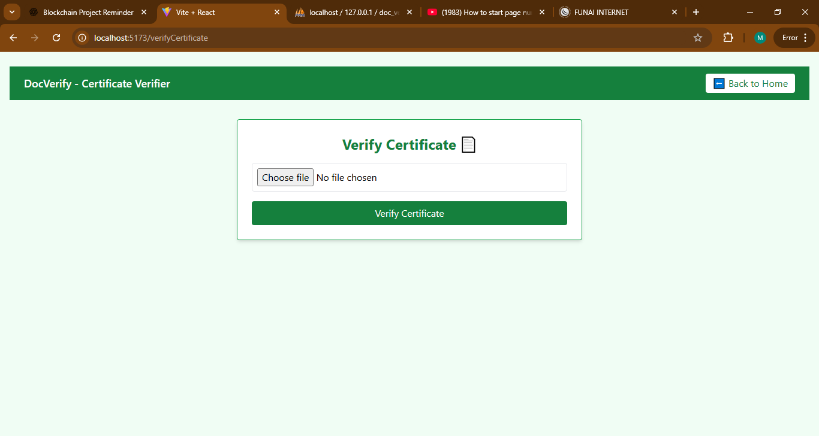
Figure 3.4: UI view of the Verification Page.
3.3.5 Program Module Design.
Program module design involves breaking down the system into smaller, manageable, and functional units (modules), each responsible for a specific task. This modular approach promotes reusability, maintainability, and simplifies debugging and testing. For this section, we focus on two core modules critical to the proposed system:
- Certificate Management Module
- Document Verification Module
- Certificate Management Module: To allow admins to upload certificates (off-chain) and record their hash (on-chain), and allow verifiers or students to verify uploaded certificates. Some Key Functions of the Module:
  - Upload a certificate for a registered student.
  - Hash the certificate using SHA-256.
  - Store the hash on the blockchain via the smart contract.
  - Upload the certificate file and its metadata to a PHP server and store it in the MySQL database.
  - Verify certificates by comparing the hash of an uploaded file with the on-chain record.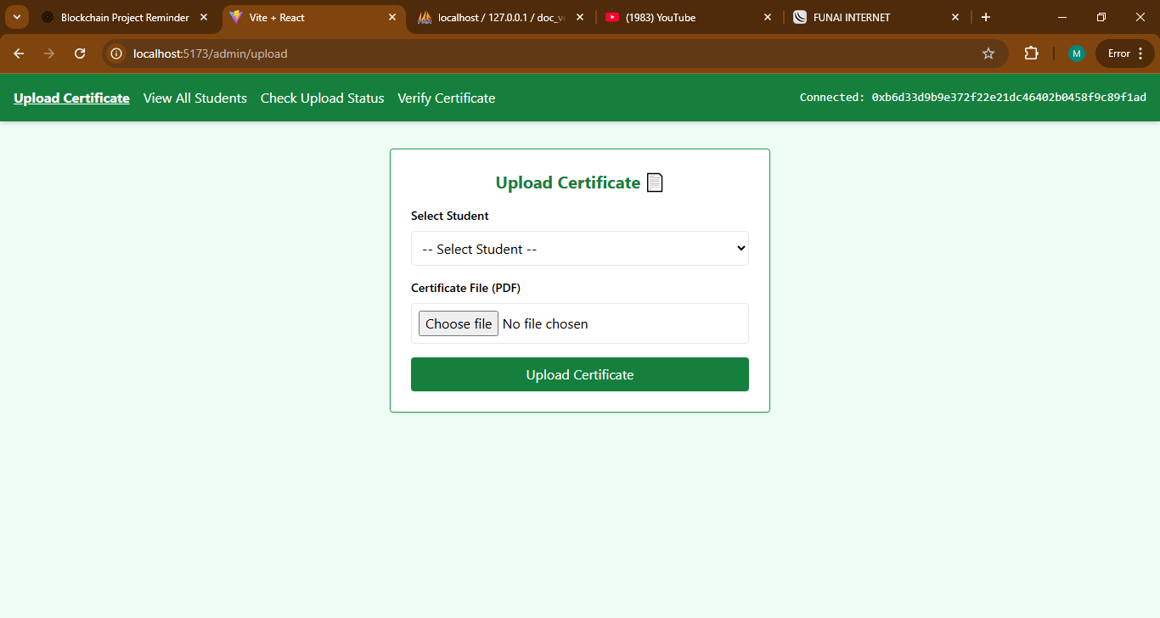
Figure 3.5: UI view of Certificate Upload Page.
- Document Verification Module: This module Allow verifiers to confirm the authenticity of uploaded certificates by comparing file hashes with those stored on the blockchain. The following are the Key Functions:
  - This module allows verifiers to upload a document to verify.
  - It also allows them to hash the uploaded document.
  - Retrieve stored document hashes for the student from the blockchain.
  - Compare and return verification result (Valid or Not Found).
3.3.6 Database Development Tool
In this project, a relational database is used to store essential student and document metadata that do not reside on the blockchain. While the blockchain stores document hashes for verification and immutability, the off-chain database stores detailed student profiles and uploaded certificates (PDF files). To build and manage this database efficiently, the following development tools and technologies were chosen:
- MySQL: MySQL was chosen as the main relational database management system (RDBMS) for this project. It offers a structured and efficient way to manage data in rows and columns and supports robust querying capabilities through Structured Query Language (SQL). MySQL is lightweight, scalable, and has extensive community support, making it a reliable choice for student and document record management.The reasons we choose MySQL include:
  - Easy integration with PHP which is used as the backend language.
  - Ability to enforce data relationships, such as linking certificates to specific students.
  - Support for indexing, and constraints compliance for data integrity.
  - Scalability for future upgrades such as analytics, notifications, or multi-department support.
- phpMyAdmin: To simplify database management, phpMyAdmin was utilised. It is a web-based tool that provides a user-friendly interface for interacting with the MySQL database. Developers and administrators can easily create tables, insert data, run SQL queries, and monitor database activity without writing raw SQL in a terminal. phpMyAdmin was used to:
  - Create and structure tables such as students and certificates,
  - Manually insert, edit, and delete records during development and testing.
  - Export and import data backups.
  - Monitor storage usage and optimise database performance.
- XAMPP: For local development, the XAMPP package was employed. It combines Apache (web server), MySQL, PHP, and phpMyAdmin into a single distribution, enabling the development environment to run entirely on a local machine without requiring internet access. This setup accelerates testing and debugging and allows us to simulate real-world backend operations. The key components of XAMPP used in this project are:
  - Apache, which was used for serving backend PHP scripts.
  - MySQL, which was used as the database engine.
  - phpMyAdmin, which was used for managing database records.
This stack allowed for the rapid building and testing of the system’s backend logic and database interactions in a controlled environment.
- Database and Blockchain Integration: While the blockchain stores immutable document hashes, the database stores complete records such as student names, matric numbers, departments, and paths to uploaded certificate files. The database and blockchain are synchronised during the upload and verification processes. For example, when a student certificate is uploaded:
  - The file is stored locally on the system since it is not yet on a live server.
  - Its metadata (e.g., student wallet, matric number, filename) is stored in MySQL.
  - The file’s hash is generated and uploaded to the blockchain.
During verification, the uploaded certificate is hashed again and compared to the hash retrieved from the blockchain, while student details are fetched from the MySQL database for reference.

3.3.7 Database Design and Structure
The database is a fundamental component of this proposed student document verification system. It plays a critical role in storing, managing, and retrieving off-chain data that complements the immutable on-chain records stored on the blockchain. While blockchain stores only cryptographic hashes and ownership proofs, the actual certificate files and detailed user information are stored securely in a centralised relational database, in this case, MySQL.
The database is designed using the principles of normalisation to ensure data consistency, reduce redundancy, and optimise query performance. It captures multiple entities relevant to the system, such as students and uploaded documents. Each table is structured to include necessary fields with appropriate data types, keys, and constraints to maintain integrity and traceability.
Key Database Tables and Their Structure
- Students Table: This table stores personal information of each registered student. Fields in this table include: student_id (Primary Key), name, matric_number, department, wallet_address, and registration_date.
- Certificates Table: This table holds metadata about uploaded certificates, linking each certificate to the student who owns it. Fields in this table include: certificate_id (Primary Key), student_id (Foreign Key), file_path, document_hash, upload_date, and verified_status.
These tables are linked using foreign key relationships to maintain referential integrity. For example, each certificate record must reference a valid student, and each verification log must point to a specific certificate.
By separating on-chain and off-chain responsibilities and connecting them through shared values like hashes and wallet addresses, this architecture ensures both high performance and tamper-proof assurance. MySQL’s mature ecosystem, support for joins, and indexing capabilities make it the ideal choice for managing this structured and relational data.
3.3.8 Input / Output Format
The input/output format defines how data is entered into the system and how it is presented or returned to users. It ensures that the interaction between users and the system is seamless, consistent, and user-friendly. In a student document verification system based on blockchain, inputs can come from different users such as admins, students, and verifiers while outputs include system responses, status messages, downloadable documents, and verification results.
- Input Formats: The Input format defines the way all users interact with the student document verification system based on blockchain technology when submitting data. Key features of the input format include:
  - File Inputs: Certificates must be uploaded in PDF format only. Uploaded files are hashed using SHA-256 before being recorded on the blockchain.
  - Text Inputs: Fields such as Full Name, Matric Number, Department are entered in text or alphanumeric formats. Empty or invalid fields are automatically rejected.
  - Wallet Inputs: Users interact with the system through Ethereum wallet addresses, automatically populated via MetaMask. Wallets must follow the standard Ethereum address format (e.g., 0xAbC123...). Unregistered wallets cannot access certain system features like certificate downloads.
  - Button/Action Inputs: Certain operations, such as “Download Certificate” or “Verify Document,” are triggered through button clicks rather than manual data entry. These actions are logged and time stamped for audit purposes.
- Output Formats: The output format defines how the system delivers results, feedback, and responses to its users after processing inputs. Outputs may be generated from off-chain operations (database queries, file retrievals) or on-chain operations (blockchain verifications). The output format include:
  - Confirmation Messages: After each successful operation, the system provides clear confirmation, such as “Certificate successfully uploaded” or “Hash stored on blockchain.” In cases of errors (e.g., failed verification), descriptive error messages are returned, such as “Verification failed: Hash not found.”
  - File Outputs: Certificates are made available as downloadable PDF files. Files are retrieved securely from the database and linked through unique identifiers to prevent unauthorized access.
  - Verification Results: For verifiers, the system returns simple and precise results, such as: “Certificate Hased found on blockchain” and “Certificate not found on blockchain.” These results are generated by comparing uploaded document hashes with blockchain records.
  - Tabular Outputs: For admins, outputs are sometimes displayed in tabular form for readability. Common columns include: Student Name, Matric Number, Wallet Address.
  - Standardised Formats: Wallet Addresses are displayed in truncated form (e.g., 0xAbC1…45De) to maintain readability while preserving uniqueness. Text Outputs are structured and concise, avoiding ambiguity.
3.3.9 Algorithm
An algorithm is a well-defined, step-by-step procedure used by a system to solve a particular problem or perform a specific task. In this Student Document Verification System based on blockchain, various algorithms are embedded within the logic of both the smart contract and the backend application to ensure accuracy, security, and efficiency.
The key operations in the system that rely on algorithmic processes include student registration, document hash generation, document storage, and verification. Below are detailed explanations of the primary algorithms used in the system:
- Student Registration Algorithm: This algorithm handles the registration of a new student into both the blockchain (on-chain) and the MySQL database (off-chain). Algorithm Steps includes:
  - Connect wallet
  - Accept student input: name, matric number, department, and wallet address.
  - Check if the wallet address already exists on the blockchain Redirect to Dashboard.
If not:
  - Call the smart contract’s registerStudent() function.
  - Store the student’s info in the MySQL database and wallet address on blockchain.
  - Return confirmation message and Redirect to Dashboard.
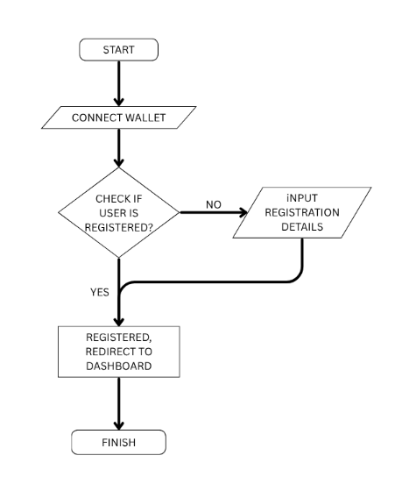
FIGURE 3.6: Registration and Login Flowchart Diagram
- Document Upload and Hashing Algorithm (Admin): This algorithm ensures secure document upload by hashing and storing it both on-chain and off-chain. Algorithm Steps includes:
  - Admin selects a PDF file (certificate).
  - Hash the file using SHA-256.
  - Call the smart contract's storeDocumentFor() with the student wallet and hash.
  - Upload the file to a folder on the localhost server, store the metadata (student wallet, file path, hash) in the database.
  - Display a success message.
- Document Verification Algorithm (Verifier): Used to check whether a given certificate has been previously stored on the blockchain. Algorithm Steps include:
  - Verifier uploads a PDF document.
  - Hash the file.
  - Query the blockchain smart contract for a matching hash.
  - If found, display student details and verification success.
  - If not found, return "Invalid document."
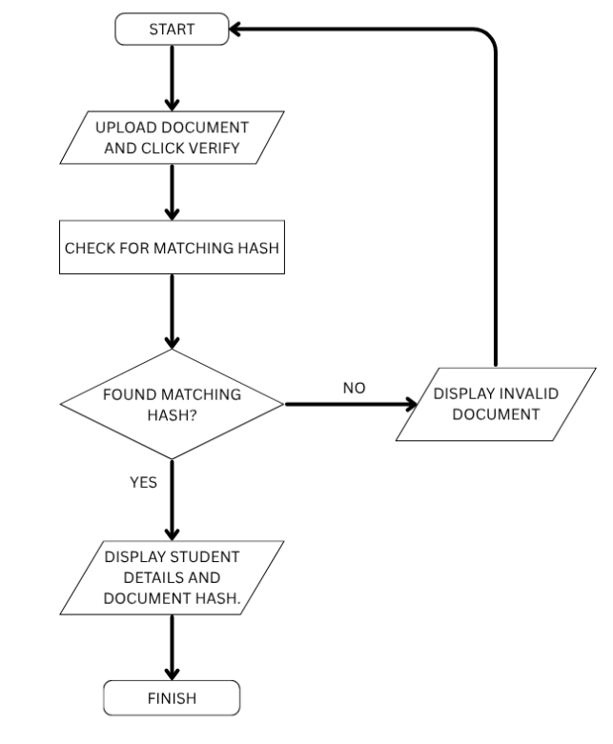
FIGURE 3.7: Document Verification Flowchart Diagram.
- Student Login Verification Algorithm: Ensures that only students whose wallet address has been registered can access their dashboard. Algorithm Steps include:
  - User connects MetaMask wallet.
  - Get wallet address from MetaMask.
  - Query the smart contract’s isStudent() function.
  - If true, redirect to dashboard.
  - Else, prompt them to register or deny access.

3.3.10 Data Dictionary
The Data Dictionary is a structured repository that defines and describes the data elements used in the Student Document Verification System based on blockchain. It provides a clear explanation of each data item, its type, source, usage, and relationship with other data items. This ensures consistency and clarity across the system, especially during development, integration, and maintenance. The data dictionary covers data from two major parts of the system:
- Off-chain (MySQL database)
- On-chain (Smart Contract stored on Ethereum blockchain)
- Off-chain (MySQL database): These data items are stored in the centralised database and primarily manage metadata and document files.
TABLE 3.4: OFF-CHAIN USER TABLE
Field Name | Description | Data Type | Source | Sample Value
id | Unique auto-increment ID | INT (PK) | MySQL Auto-gen | 1
name | Full name of the student | VARCHAR(100) | Student registration  input | Miracle Onyedika Ngwube
matric_number | Student's matriculation number | VARCHAR(50) | Student registration input | 2021/CSC/18901
department | Student’s academic department | VARCHAR(100) | Student registration input | Computer Science
wallet_address | Ethereum wallet address of the student | VARCHAR(255) | MetaMask | 0xAbcd123...7890
file_path | Location of the uploaded PDF on the localhost server | VARCHAR(255) | File | upload/certs/miracle_ngwube.pdf
file_hash | SHA256 hash of the uploaded document | VARCHAR(255) | Hash function | a8c3f6a...6d9f38e3
upload_status | Status of document upload (complete/incomplete) | ENUM | System Generated | Complete
created_at | Timestamp of registration or upload | TIMESTAMP | System Generated | 2025-07-25 14:12:43

- On-chain Data Dictionary (Smart Contract): These data elements are stored and managed on the Ethereum blockchain using Solidity in the smart contract.
TABLE 3.5: ON-CHAIN USER DATA TABLE
Variable Name | Description | Type | Source | Sample Value
students | Mapping of wallet to registration status | mapping(address => bool) | Smart Contract | 0xAbcd… => true
documents | Mapping of wallet to array of document hashes | mapping(address => bytes32[]) | Smart Contract | [0x1ab3…, 0x3cf9…]
fileHash | A document hash stored on-chain for a user | bytes32 | Generated from the document | 0x2f9…3dE0

CHAPTER FOUR
SYSTEM IMPLEMENTATION, TESTING AND RESULTS
4.1 System Implementation
System implementation refers to the actual construction and deployment of the Student Document Verification System based on blockchain technology. It involves translating the design into a working system by developing and integrating the frontend interface, backend logic, blockchain smart contracts, and database interactions. This stage is crucial, as it transforms theoretical models and plans into a functional application that meets user and project requirements. The implementation of this system in this section covers hardware and software requirements, programming tools and languages used, menu and module development, and integration of key functionality.
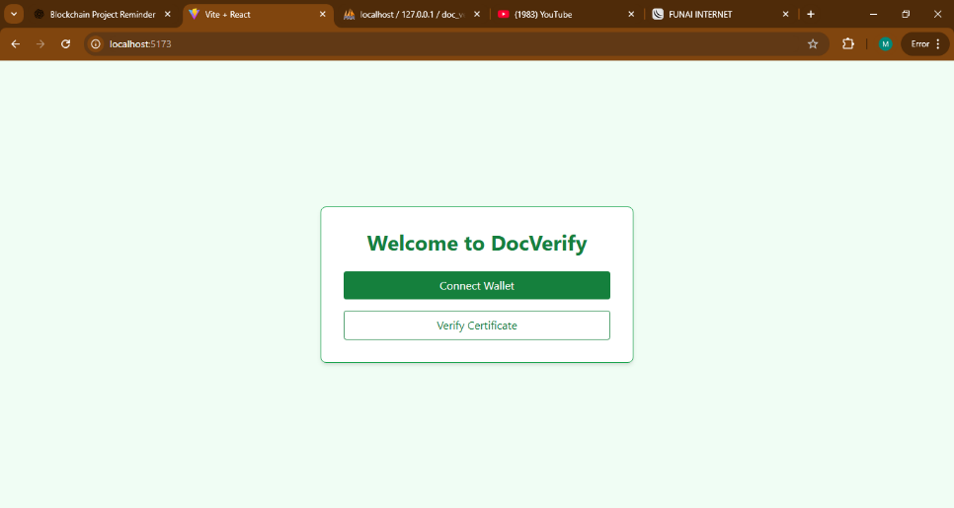
Figure 4.1: Landing Page of the System.
4.1.1 Hardware Requirement
The successful design and implementation of the student document verification system based on blockchain technology required a laptop with suitable hardware specifications to handle software installations, smart contract compilation, local blockchain emulation, database setup, and frontend/backend development. The development process involved using tools like Ganache, Truffle, PHP, MySQL, and React, which demand a moderate to high-performance computing environment. Below are the key hardware specifications of the laptop used during the system development phase:
- Processor: Intel Core i5 (8th Generation).
- RAM: 8 GB.
- Storage: 256 GB SSD.
- Display: 15.6-inch HD Display.
- Operating System: Windows 10 Pro.
- Internet Connectivity: Wi-Fi Enabled.
4.1.2 Software Requirement
The successful implementation of the student document verification system required a variety of software tools and environments. These tools were chosen to support the development of a decentralised application that integrates smart contract technology (for on-chain verification) with a traditional web application and database system (for user interaction and document management). The major software components used are grouped below based on their specific roles:
- Operating System: A. Windows 10 Pro (64-bit)
- Frontend Development Tools:
  - React.js
  - JavaScript (ES6)
  - Tailwind CSS / CSS3
  - MetaMask Extension
- Smart Contract Development Tools:
  - Solidity (v0.8.0)
  - Truffle Suite
  - Ganache
- Backend Development Tools
  - PHP (v8.x).
  - XAMPP.
- Database Management
  - MySQL (via XAMPP).
- Package Managers and Tools
  - Node.js and npm.
  - Web3.js.
4.1.3 Program Development
The development of the student document verification system was carefully structured to ensure both functionality and maintainability. The system was built using a modular architecture consisting of three main components:
I. The blockchain layer (on-chain),
II. The user interface (frontend),
III. The backend server (off-chain).
The smart contract was developed using Solidity, a high-level programming language specifically designed for Ethereum. This contract handled core blockchain functionalities such as registering student wallet addresses, storing document hashes, and enabling secure and tamper-proof verification. To ensure code quality and test deployment, Truffle was used as the development environment, while Ganache provided a local blockchain for testing.
The frontend of the system was developed using React.js, which allowed for the creation of a dynamic and interactive user interface. Students and administrators interacted with the system through this interface. Key features, such as MetaMask wallet connection, file uploads, document hash generation, and contract interaction, were all handled smoothly using React in combination with Web3.js, which facilitated direct blockchain communication from the browser.
The backend was implemented using PHP, chosen for its simplicity and compatibility with server-side processing tasks such as form submission, file handling, and database queries. MySQL was used as the database system to store student records, certificate file information, and other related metadata. Together, PHP and MySQL enabled efficient off-chain data handling and integration with the blockchain component.
4.1.3.1 Choice of Programming Language
During system development, the following programming languages and technologies were selected based on their strengths and suitability for specific parts of the system:
I. Solidity: For writing the Ethereum smart contract.
II. React.js (JavaScript): For building a responsive and interactive web-based frontend.
III. Web3.js: To enable interaction between the React frontend and the Ethereum blockchain.
IV. PHP: For handling backend logic, file uploads, and database connections.
V. MySQL: For managing and storing off-chain student records and document metadata.
These technologies were selected to work together seamlessly in delivering a hybrid blockchain and web-based application.
4.1.3.2 Language Justification
Each technology used in the development of the system was carefully chosen based on its strengths and compatibility with the system’s requirements:
Solidity was selected because it is the industry standard language for developing Ethereum smart contracts. It provides native support for features such as mapping, access control, modifiers, and event emission, all of which were essential in handling student registrations and verifying document hashes securely on the blockchain.
React.js was used for its ability to build scalable and dynamic user interfaces. It allows the creation of reusable components and handles state efficiently, which was important for features like switching between admin and student views, and updating the UI after blockchain interactions.
Web3.js served as a bridge between the React application and the Ethereum network. It made it possible to read data from and write data to the deployed smart contract, as well as listen to blockchain events and handle wallet authentication.
PHP was chosen for the backend due to its flexibility in handling file uploads and managing communication with the MySQL database. It is well-documented, widely supported, and runs efficiently on most web servers, making it ideal for handling server-side logic in a lightweight manner.
MySQL was selected as the database management system because of its robustness in handling relational data. It provided efficient data storage for student records, including name, matriculation number, department, wallet address, and file metadata (such as certificate file path and upload status).
Together, these languages and tools formed a solid development stack for a secure, decentralised, and user-friendly document verification platform.
4.1.4 Main Menu Implementation
The main menu is a vital component of the Student Document Verification System, acting as the central navigation point for users after a successful login. The menu is designed to be role-sensitive, meaning the content and options it displays vary depending on whether the user is an Admin or a Student. This ensures that each user is presented with only the features they are authorised to use, thereby improving both usability and security.
The implementation of the main menu was carried out using React.js for the frontend structure and Tailwind CSS for styling. The interface is dynamic and responsive, adapting seamlessly to different screen sizes. The design follows a tab-based navigation layout, allowing users to interact with different sections without full page reloads, improving performance and user experience.
- Admin Main Menu: For Admin, the main menu provides access to a multi-functional dashboard with the following core options:
  - Upload Certificate: This tab enables the admin to upload certificates for registered students.
  - View All Students: Displays a comprehensive list of all registered students.
- Student Main Menu: For students, the main menu is simplified to avoid overwhelming them with admin-level controls. Upon successful login (after wallet connection and verification), students are redirected to their dashboard, which presents the following options:
  - View My Certificate.
  - Download their certificate in PDF format
The main menu implementation is a carefully crafted component of the system that not only organises system features into logical sections but also enforces access control and provides a seamless user experience. Its adaptability, dynamic behaviour, and role-based rendering are central to the success of the entire document verification platform.
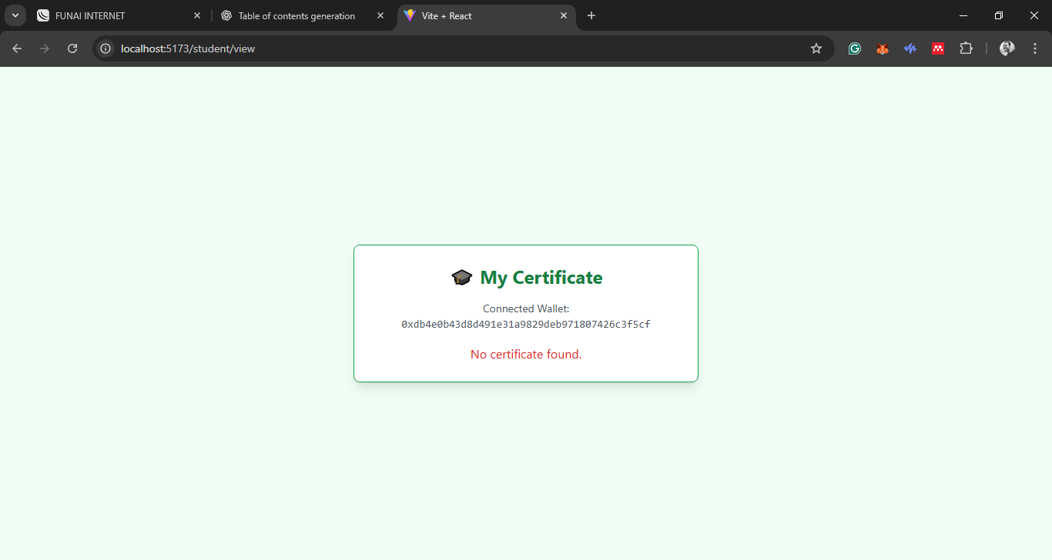
Figure 4.2: Student View Certificate Page (with no certificate uploaded).
4.1.5 Sub Menu Implementation
The sub-menu implementation involves the development of all the secondary pages or functional screens that users interact with after selecting an option from the main menu. These submenus are integral to the system’s usability, as they provide access to detailed operations such as certificate upload, verification, and user registration.
The submenus were implemented using React.js for the frontend, which enabled the creation of interactive and component-based views. Each submenu was designed as a separate component and integrated into the routing logic using React Router to enable seamless transitions between views. The submenus implemented include:
- Upload Certificate Submenu: This submenu allows the admin to upload a certificate by selecting a student and uploading a PDF file. Once uploaded, the file is hashed with a click of a button and stored on the blockchain, while the actual file and metadata are stored off-chain in a MySQL database via a PHP backend API.
- View All Students Submenu: This displays a list of all registered students in a tabular format. Admins can view student details such as name, matric number, department, and wallet address.
4.1.6 Program Module Implementation
The Program Module Implementation represents the practical realisation of the system’s major components. Each module performs a specific role while integrating seamlessly to provide a secure and reliable document verification process. Three primary modules were implemented:
- Certificate Management Module: This module is designed for administrators to handle certificate-related tasks. It allows certificate upload and storage of certificate details both on-chain and off-chain. This module ensures certificates are securely uploaded and traceable across both blockchain and database layers.
- Document Verification Module: This module is used by verifiers such as employers or institutions to confirm the authenticity of a student’s certificate. This module ensures fast, automated, and tamper-proof verification without exposing sensitive student data.
- Student Access Module: This module enables students to interact with the system using their blockchain wallets and provides them with direct access to their academic records. This module ensures students have lifelong, secure access to their credentials without relying on physical copies.
Figure 4.3: UI view of Upload Certificate Page.
4.2 System Testing
System testing is a critical phase in the software development lifecycle, intended to validate that all components of the system function correctly and as expected. For the student document verification system based on blockchain technology, testing focused on ensuring data integrity, accuracy of verification, smooth interaction between modules, and proper integration between the frontend, smart contract, and backend systems.
To achieve comprehensive validation, unit testing was selected as the primary testing strategy. This approach allows individual components or modules of the system to be tested in isolation before being integrated. It ensures that each function, such as registering a student, uploading a certificate, verifying a document, or interacting with the blockchain smart contract, works as intended.
4.2.1 Test Plan
The test plan outlines the approach used to validate system modules. In this project, unit testing was used to verify the correct operation of individual modules and smart contract functions before integrating them into the larger application. Unit testing provides confidence that every part of the system performs independently and handles errors gracefully before full deployment. Key modules tested include:
I. Wallet Connection Module: Ensures MetaMask or any Web3 wallet connects properly to the application.
II. Student Registration Module: Verifies that a student's details and wallet address are stored both on-chain and in the database.
III. Certificate Upload Module (Admin): Confirms successful upload of certificate files to the database and hash to the blockchain.
IV. Document Verification Module (Verifier): Checks that uploaded documents are hashed and matched correctly with existing blockchain records.
V. Blockchain Interaction Functions: Validates functions like storeDocumentFor, getDocumentsFor, and verifyDocument.
All tests were performed in a local environment using Ganache for the Ethereum blockchain simulation, and PHP + MySQL for database integration testing.

4.2.2 Test Data
The following test data was created to evaluate the accuracy and performance of the system. Each module was supplied with realistic inputs to observe expected versus actual outcomes. The test data included sample student records, certificate files, and verification requests.
TABLE 4.1: TEST DATA TABLE
Test ID | Module Tested | Input | Expected Output | Actual Output | Result
T001 | Wallet Connection | MetaMask wallet connection | Wallet address retrieved and displayed | Wallet address successfully connected | Pass
T002 | Student Registration | Miracle Onyedika, Matric: 2021/CSC/001, Wallet: 0x123... | Stored in Database and blockchain | Data stored successfully both on-chain and off-chain | Pass
T003 | Certificate Upload | Certificat.pdf for Miracle Onyedika | Hash stored on blockchain, file stored in database | Both blockchain and Database entries created | Pass
T004 | Document verification | Upload matching certificate.pdfHash | Hash matches stored value, returns “Valid Document” | Verification succeeded, result: "Valid Document" | Pass
T005 | Document verification | Upload altered certificate.pdfHash | Hash mismatch, returns “Document not verified” | Verification failed, result: "Document not verified" | Pass
T006 | View Registrated Students | None | List of all students fetched from database | All registered students displayed with correct details | Pass

The unit tests demonstrated that the core functionalities of the system were robust, reliable, and performed well under normal operating conditions. Testing helped reveal minor UI bugs and enhanced system error handling, which were fixed before deployment.

4.3. Results
The result phase presents the findings obtained from implementing and testing the student document verification system based on blockchain technology. It provides a comparison between expected outcomes and actual system behaviour, assesses the system’s performance in terms of speed, accuracy, and reliability, highlights any limitations encountered during testing, and discusses the significance of the observed results in the context of the system’s objectives.
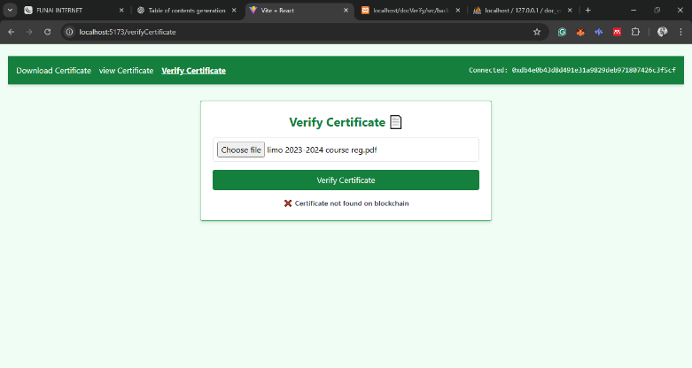
Figure 4.4:UI view of Verify Certificate Page (with invalid certificate.)
4.3.1 Actual Test Result versus Expected Test Result
System testing involved simulating user behaviours and comparing what the system did (actual results) against what it was supposed to do (expected results). The test cases were grouped by modules and executed multiple times to ensure consistency and reliability.
TABLE 4.2: TEST RESULT TABLE
Test ID | Test Scenarios | Expected results | Actual results | Status
T001 | Admin connects the wallet | Access granted if the wallet matches the admin address | Wallet successfully validated as admin | Passed
T002 | Non-admin tries accessing the admin dashboard | Access denied and redirected to the home page | Access denied but no Correct redirection occurred | Failed
T003 | Student registration with valid data | Wallet and details registered on-chain and Databases | Data was saved correctly on both layers | Passed
T004 | Re-registered the same wallet address | Error message shown or redirected to the dashboard | Student redirected to dashboard | Passed
T005 | Verifier upload a valid certificate for checking | System returns "Certificate Valid" | Correct verification result returned | Passed
T006 | Verifier upload a mismatched certificate | System returns "Certificate Invalid" | Accurate mismatch notification | Passed
T007 | Admin uploads a document without a file | Error message shown | Error correctly displayed | Passed
T008 | Network error during blockchain interaction | Error handled gracefully without crashing the app | Error displayed, user prompted to retry | Passed

The results show that the system met its expected outcomes for all major functionalities, particularly in blockchain interactions and certificate verification.
4.3.2 Performance Evaluation
Performance was evaluated based on three key metrics: response time, accuracy of document verification, and system reliability. The system exhibited satisfactory performance across all metrics:
- Response Time: The system responded within 3- 5 seconds on average when interacting with the Ethereum smart contract (on Ganache), and under 1 second for database operations.
- Accuracy: Document verification returned correct results in all test cases. Matching hashes confirmed document authenticity, while mismatches accurately triggered verification failures.
- Reliability: The system operated reliably over multiple transactions, including student registrations, document uploads, and verification operations, without crashes or data loss.
Furthermore, error handling mechanisms ensured that invalid inputs or unauthorised actions were managed well, improving overall user experience.
4.3.3 Limitation of the Result
Despite the successful outcomes, several limitations were identified during system testing and evaluation:
- Local Blockchain Environment: Testing was conducted using Ganache (a local Ethereum simulator), which may not fully reflect real-world blockchain behavior in live environments like Ethereum mainnet or testnet. Network latency, gas fees, and block confirmation delays were not realistically simulated.
- Single Certificate per Student: The current implementation assumes one certificate per student. Extending it to handle multiple document types per student may require additional logic and data structures.
- Limited Error Scenarios: Some edge cases (e.g., loss of connection during upload, corrupted files, malformed metadata) were not fully tested due to time constraints.
- Scalability Testing: The system has not yet been stress tested with hundreds or thousands of students and certificates, which would be necessary to evaluate its performance under large-scale deployment.

4.3.4 Results and Discussions
The results demonstrate that the student document verification system based on blockchain technology meets its primary objectives, securing and verifying academic credentials with transparency and immutability. The successful integration of smart contracts for on-chain data storage and verification, combined with off-chain certificate file management via PHP and MySQL, provided a hybrid solution that balances decentralisation with efficient file handling. The implications of the results are as follows:
- Increased Trust: Storing certificate hashes on a public blockchain ensures documents cannot be tampered with after issuance, thereby increasing confidence in their authenticity.
- Efficiency: Real-time verification removes the manual burden of checking documents against physical records.
- Access Control: The use of wallet-based authentication ensures that only authorised users can perform sensitive actions like uploading certificates or registering students.
While the system performs well in its current state, future improvements such as deploying to a live blockchain, supporting multiple documents per student, and adding a notification system would further enhance its robustness and scalability.
4.4 System Security
System security is essential in a student document verification system, especially when dealing with sensitive academic records and blockchain transactions. The system was developed with robust security mechanisms in place to ensure data privacy, access control, and resistance to tampering or unauthorised use.
One of the key security features is blockchain integration. Documents uploaded by the admin are hashed and stored on the Ethereum blockchain. This ensures immutability, meaning once a document's hash is stored on-chain, it cannot be modified or tampered with. This strengthens trust in the system, especially during the verification process.
The system also employs wallet-based authentication using MetaMask. Users must connect their Ethereum wallets to access their respective dashboards (admin and student). This form of authentication adds an extra layer of protection since it requires ownership of a valid blockchain wallet.
To further enforce access control, Solidity smart contract modifiers are used. These modifiers restrict certain functions, such as uploading document hashes to admin-only access. Verifiers and students can only read or verify data without being able to alter the blockchain or database content.
Uploaded files undergo validation checks to confirm they are PDF documents and within the allowed file size before being accepted. Summary of Security Measures:
I. Blockchain-based data integrity (hashing & immutability).
II. MetaMask wallet login for identity verification.
III. Smart contract access control with only Admin and related modifiers.
4.5 System Integration
System integration refers to how various independent modules and technologies work together to deliver a unified student document verification experience. The system consists of multiple layers:
- Frontend (React.js): The user interface is developed using React to provide real-time, dynamic interaction. It interacts with both the blockchain through Web3 and the backend server through HTTP API requests.
- Smart Contract (Solidity): Handles the secure registration of students and stores document hashes immutably. It enforces role-based permissions for admin, verifier, and students.
- Blockchain Layer (Ganache, Ethereum): This layer is responsible for smart contract deployment, transaction processing, and maintaining data integrity.
- Backend (PHP & MySQL): Handles off-chain storage of certificate files and student metadata. Also provides APIs that interface with the frontend for certificate retrieval and search operations.
During system operation, users first connect their MetaMask wallets through the frontend, which interacts with the blockchain to determine their role as student or admin. Based on the identified role, the system loads the corresponding dashboard interface. When an admin uploads a certificate, the file is hashed and the hash is stored immutably on the blockchain, while the actual PDF file and related metadata are stored in the backend database. For verification, a verifier uploads a certificate, which is rehashed and compared with the blockchain record to confirm authenticity. This integrated flow ensures that the blockchain guarantees security and integrity, while the backend provides efficient storage and retrieval of large files.
This integration allows for seamless interaction between on-chain verification and off-chain document storage. Each component complements the other to ensure fast access and reliable verification.

CHAPTER FIVE
SUMMARY, CONCLUSION AND RECOMMENDATIONS
5.1 Summary
This project was designed to address the persistent issues related to document forgery, time consumed by manual verification, and lack of transparency in student academic records. The solution proposed and implemented is a student document verification system based on blockchain technology, which combines the strengths of decentralised technology with traditional web development practices. The system was structured with three primary user roles: the admin, who uploads certificate data; the student, who logs in to access their certificate; and the verifier, who is able to confirm the authenticity of a certificate by checking its hash on the blockchain. The application was built using React.js for the frontend interface, Solidity smart contracts on the Ethereum blockchain for decentralised storage of document hashes, and PHP/MySQL for managing and storing user data and uploaded certificates off-chain.
A modular development approach was employed to ensure the separation of concerns, which improved scalability and maintainability. Smart contract functions were used to handle student registration and document hash storage on-chain, while the backend PHP scripts managed off-chain document uploads and metadata storage. The system passed all unit-level test scenarios, confirming its reliability and performance under expected conditions. Key modules such as Certificate Management and Document Verification were tested for data accuracy, transaction validity, and real-time user feedback, all of which functioned as expected. Security and access control were reinforced using smart contract modifiers and MetaMask integration for authentic wallet interaction.
5.2 Conclusion
In conclusion, the implementation of this student document verification system based on blockchain technology proves that blockchain technology can be effectively leveraged to eliminate certificate fraud, reduce manual verification bottlenecks, and create a secure, transparent, and trustworthy process for verifying academic certificates. The immutable nature of blockchain ensures that once a document’s hash is uploaded, it cannot be altered or deleted, thereby protecting the integrity of academic credentials. Furthermore, the use of a hybrid architecture incorporating both on-chain and off-chain components makes the system practical and cost-efficient for academic institutions with limited infrastructure budgets.
The separation of responsibilities among user roles, combined with the secure use of MetaMask wallet authentication, ensures that each user can only access and perform actions appropriate to their role. This greatly minimises the risk of unauthorised data access. Overall, the project provides a meaningful solution to one of the pressing challenges faced by educational institutions today and lays the foundation for more advanced academic verification systems in the future.
5.3 Recommendations
Although the system nearly met its objectives and functioned well in a controlled environment, several practices are recommended for the good use of the system.
- Users (students, admins, and verifiers) should always access the system using the latest versions of modern browsers such as Google Chrome, Mozilla Firefox, or Microsoft Edge. This ensures compatibility with MetaMask integration and prevents security vulnerabilities.
- Students and admins should maintain secure control of their Ethereum wallets (via MetaMask). Wallet private keys and seed phrases must never be shared to prevent unauthorised access to certificate records.
- Users should avoid renaming or altering PDF files outside the system, as any modification will produce a different hash and fail verification.
- Verifiers should always upload the original certificate PDF file received from the student. Screenshots, images, or scanned versions should not be used, as they may alter the file structure and lead to mismatches in blockchain hash verification.
- Institutions should provide brief user guides or FAQs explaining wallet connection, certificate upload, and verification steps.

REFERENCE
Alshahrani, M. Y. (2021). Implementation of a blockchain system using improved elliptic curve cryptography algorithm for the performance assessment of the students in the e-learning platform. Applied Sciences, 12(1), 74.
Awaji, B., Solaiman, E., & Marshall, L. (2020, July). Blockchain-based trusted achievement record system design. In Proceedings of the 5th International Conference on Information and Education Innovations (pp. 46-51).
Bucea-Manea-Țoniş, R., Martins, O. M., Bucea-Manea-Țoniş, R., Gheorghiță, C., Kuleto, V., Ilić, M. P., & Simion, V. E. (2021). Blockchain technology enhances sustainable higher education. Sustainability, 13(22), 12347.
Camilleri, A. F., & Grech, A. (2018). Blockchain in Education: Feasibility, challenges, benefits and risks for formal and non-formal credentials. JRC Publications.
Cahyadi, D., Faturahman, A., Haryani, H., & Dolan, E. (2021). Bcs: Blockchain smart curriculum system for verification student accreditation. International Journal of Cyber and IT Service Management, 1(1), 65-83.
Chowdhary, A., Agrawal, S., & Rudra, B. (2021, August). Blockchain based framework for student identity and educational certificate verification. In 2021 Second International Conference on Electronics and Sustainable Communication Systems (ICESC) (pp. 916-921). IEEE.
Deenmahomed, H. A., Didier, M. M., & Sungkur, R. K. (2021). The future of university education: Examination, transcript, and certificate system using blockchain. Computer Applications in Engineering Education, 29(5), 1234-1256.
Ghazali, O., & Saleh, O. S. (2018). A graduation certificate verification model via utilization of the blockchain technology. Journal of Telecommunication, Electronic and Computer Engineering (JTEC), 10(3-2), 29-34.
Han, M., Li, Z., He, J., Wu, D., Xie, Y., & Baba, A. (2018, September). A novel blockchain-based education records verification solution. In Proceedings of the 19th annual SIG conference on information technology education (pp. 178-183).
Hsu, C. S., Tu, S. F., & Chiu, P. C. (2022). Design of an e-diploma system based on consortium blockchain and facial recognition. Education and Information Technologies, 1-25.
Lamkoti, R. S., Maji, D., Gondhalekar, A. B., & Shetty, H. (2021). Certificate verification using blockchain and generation of transcript. Int. J. Eng. Res. Technol, 10(3), 62.
Rasool, S., Saleem, A., Iqbal, M., Dagiuklas, T., Mumtaz, S., & ul Qayyum, Z. (2020). Docschain: Blockchain-based IoT solution for verification of degree documents. IEEE Transactions on Computational Social Systems, 7(3), 827-837.
Saleh, O. S., Ghazali, O., & Rana, M. E. (2020). Blockchain based framework for educational certificates verification. Journal of critical reviews.
Shakan, Y., Kumalakov, B., Mutanov, G., Mamykova, Z., & Kistaubayev, Y. (2021). Verification of university student and graduate data using blockchain technology. International Journal of Computers Communications & Control, 16(5).
Wahyuningsih, T., Oganda, F. P., & Anggraeni, M. (2021). Design and implementation of digital education resources blockchain-based authentication system. Blockchain Frontier Technology, 1(01), 74-86.
Zheng, Y. (2021). Design of a blockchain-based e-portfolio evaluation system to assess the education and teaching process. International Journal of Emerging Technologies in Learning (iJET), 16(5), 261-280.

APPENDIX
Appendix A: Source Code (smart contract code)
// SPDX-License-Identifier: MIT
pragma solidity ^0.8.0;
contract DocumentVerification {
struct Student {
string matricNumber;
bool isRegistered;
}
address public admin;
mapping(address => Student) private students;
mapping(address => bytes32[]) private userDocuments;
mapping(bytes32 => bool) private documentHashes;
mapping(bytes32 => uint256) private uploadTimestamps;
event StudentRegistered(address student, string matricNumber);
event DocumentStored(address student, bytes32 hash, uint256 timestamp);
modifier onlyAdmin() {
require(msg.sender == admin, "Not admin");
_;
}
constructor() {
admin = msg.sender;
}
// Self-registration for students
function registerStudent(string calldata matricNumber) external {
require(!students[msg.sender].isRegistered, "Already registered");
students[msg.sender] = Student({
matricNumber: matricNumber,
isRegistered: true
});
emit StudentRegistered(msg.sender, matricNumber);
}
// Admin uploads on behalf of student
function storeDocumentFor(address student, bytes32 hash) external onlyAdmin {
require(students[student].isRegistered, "Student not registered");
require(!documentHashes[hash], "Hash already exists");
userDocuments[student].push(hash);
documentHashes[hash] = true;
uploadTimestamps[hash] = block.timestamp;
emit DocumentStored(student, hash, block.timestamp);
}
// Student uploads for self
function storeDocument(bytes32 hash) external {
require(students[msg.sender].isRegistered, "Not registered");
require(!documentHashes[hash], "Hash already exists");
userDocuments[msg.sender].push(hash);
documentHashes[hash] = true;
uploadTimestamps[hash] = block.timestamp;
emit DocumentStored(msg.sender, hash, block.timestamp);
}
function getMyDocuments() external view returns (bytes32[] memory) {
return userDocuments[msg.sender];
}
function getDocumentsFor(address student) external view returns (bytes32[] memory) {
return userDocuments[student];
}
function verifyDocument(bytes32 hash) external view returns (bool) {
return documentHashes[hash];
}
function isRegistered(address student) external view returns (bool) {
return students[student].isRegistered;
}
function getMatricNumber(address student) external view returns (string memory) {
require(students[student].isRegistered, "Student not found");
return students[student].matricNumber;
}
function getUploadDate(bytes32 hash) external view returns (uint256) {
require(documentHashes[hash], "Hash not found");
return uploadTimestamps[hash];
}
function updateAdmin(address newAdmin) external onlyAdmin {
admin = newAdmin;
}
function getStudentInfo(address student) external view returns (string memory matric, bool registered) {
matric = students[student].matricNumber;
registered = students[student].isRegistered;
}
}

Appendix B: Sample Output
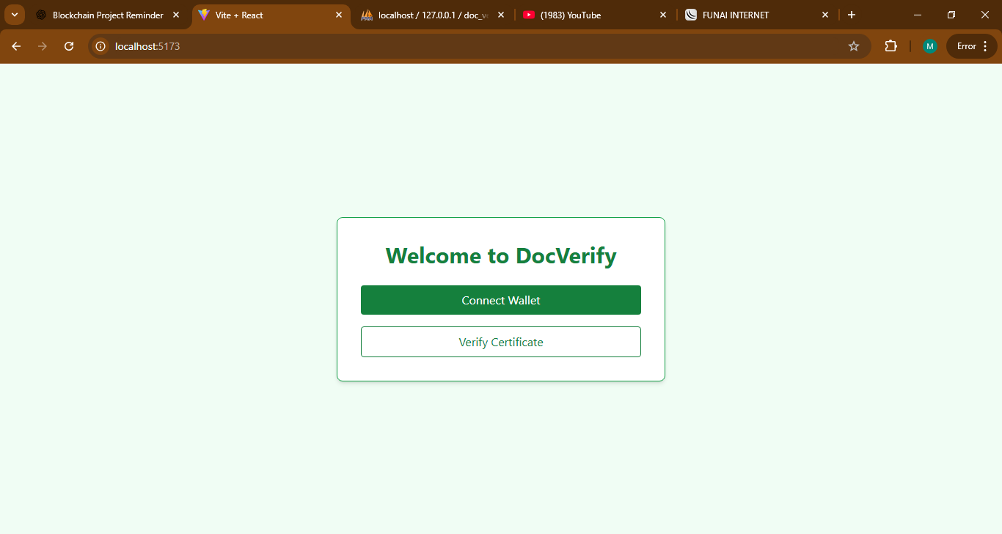
Landing page
Upload page
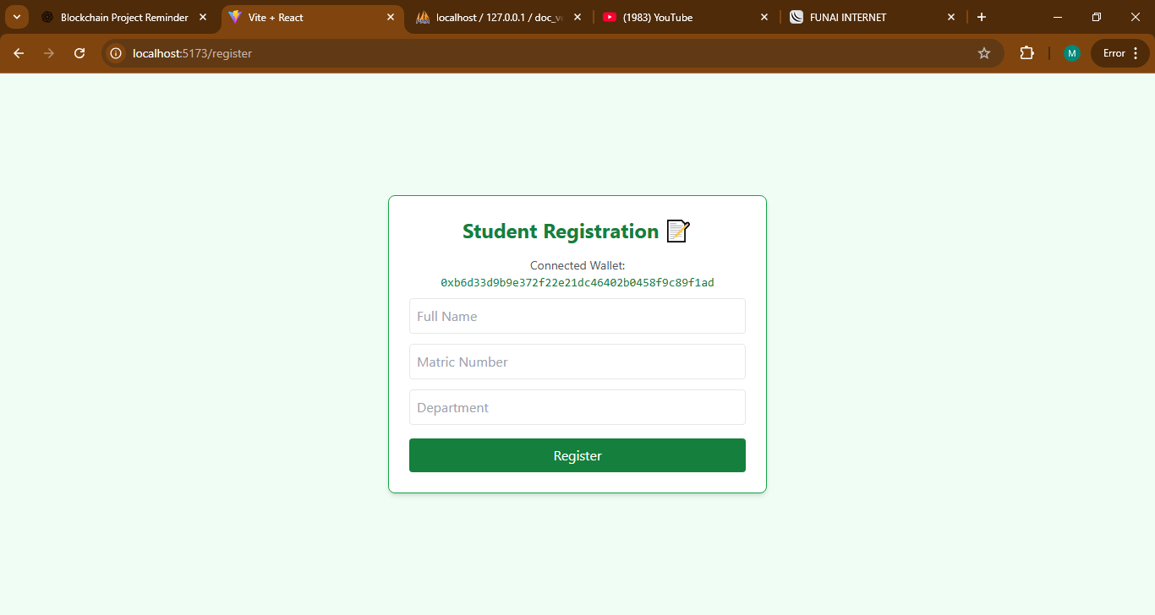
Registration page
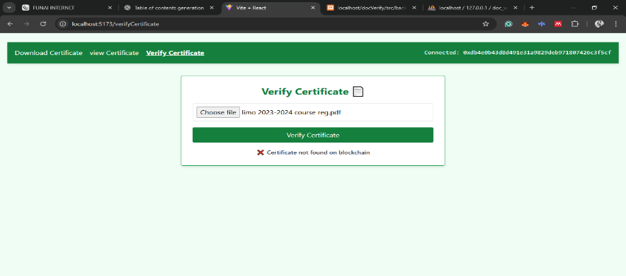
Verification page
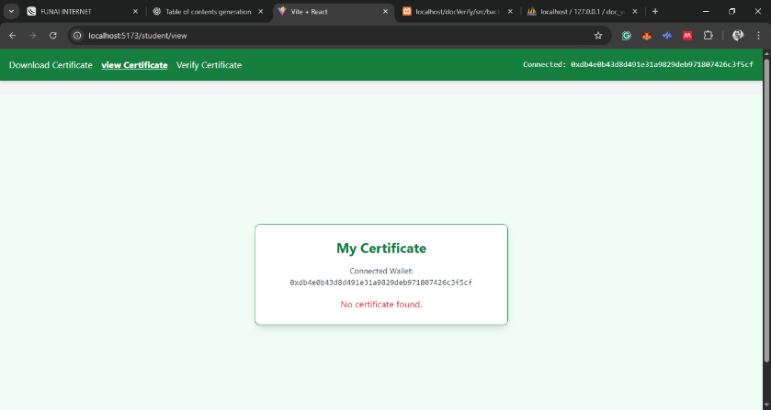
View Certificate Page.

